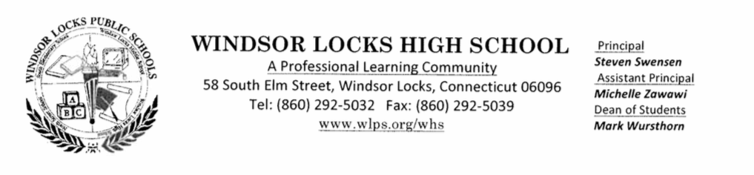

TO: All Faculty and Staff

FROM: Steve

DATE: January 12, 2015

RE: Midterm Exam Schedule (Revised)

**Tuesday, January 13, 2015 will be a regular Wednesday – Friday scheduled school day from 7:30 am – 2:15 pm with periods 1 through 7 meeting.**

|  |  |
| --- | --- |
| January 14, 2015 | 7:45 am – 12:00 pm |
| Period 1 Exam | 7:45 am – 9:45 am |
| Period 2 Exam | 10:00 am – 12:00 pm |

|  |  |
| --- | --- |
| January 15, 2015 | 7:45 am – 12:00 pm |
| Period 3 Exam | 7:45 am – 9:45 am |
| Period 4 Exam | 10:00 am – 12:00 pm |

|  |  |
| --- | --- |
| January 16, 2015 | 7:45 am – 12:00 pm |
| Period 5 Exam | 7:45 am – 9:45 am |
| Period 6 Exam | 10:00 am – 12:00 pm |

|  |  |
| --- | --- |
| January 21, 2015 | 7:45 am – 12:00 pm |
| Period 7 Exam | 7:45 am – 9:45 am |
| Make-Up Exams | 10:00 am – 12:00 pm |

**Busses will run at 12:00pm on exam days and on Wednesday, January 21, 2015 they will run at 10:00 am with a late bus at 12:00 pm for any students needing to stay for a make-up exam.**