|  |
| --- |
| **Label the Ear Anatomy Diagram** |

Sound is collected by the pinna (the visible part of the ear) and directed through the outer ear canal. The sound makes the eardrum vibrate, which in turn causes a series of three tiny bones (the hammer, the anvil, and the stirrup) in the middle ear to vibrate. The vibration is transferred to the snail-shaped cochlea in the inner ear; the cochlea is lined with sensitive hairs which trigger the generation of nerve signals that are sent to the brain.

Read the definitions below, then label the ear anatomy diagram.

[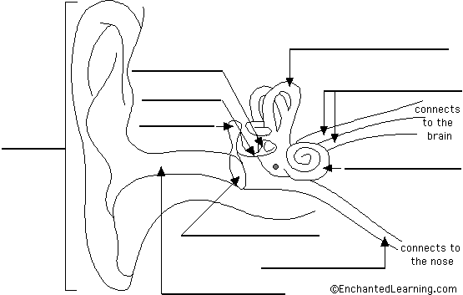](http://www.enchantedlearning.com/label/anatomy.shtml)

|  |  |
| --- | --- |
| **anvil** - (also called the incus) a tiny bone that passes vibrations from the hammer to the stirrup. **cochlea** - a spiral-shaped, fluid-filled inner ear structure; it is lined with cilia (tiny hairs) that move when vibrated and cause a nerve impulse to form. **eardrum** - (also called the tympanic membrane) a thin membrane that vibrates when sound waves reach it. **Eustachian tube** - a tube that connects the middle ear to the back of the nose; it equalizes the pressure between the middle ear and the air outside. When you "pop" your ears as you change altitude (going up a mountain or in an airplane), you are equalizing the air pressure in your middle ear. **hammer** - (also called the malleus) a tiny bone that passes vibrations from the eardrum to the anvil. | **nerves** - these carry electro-chemical signals from the inner ear (the cochlea) to the brain. **outer ear canal** - the tube through which sound travels to the eardrum. **pinna** - (also called the auricle) the visible part of the outer ear. It collects sound and directs it into the outer ear canal **semicircular canals** - three loops of fluid-filled tubes that are attached to the cochlea in the inner ear. They help us maintain our sense of balance. **stirrup** - (also called the stapes) a tiny, U-shaped bone that passes vibrations from the stirrup to the cochlea. This is the smallest bone in the human body (it is 0.25 to 0.33 cm long). |