Contact: Steven Swensen  Windsor Locks High School  Phone 860-292-5713  Fax 860-292-5039  sswensen@wlps.org | 58 S. Elm St.  Windsor Locks, CT 06096 | Windsor Locks High School

Press Release

Windsor Locks High School Student

Rotary Youth Leadership
Windsor Locks, CT September 10, 2015:
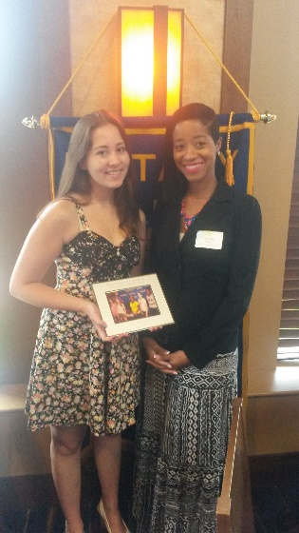
Lily Muzzarelli, a junior at Windsor Locks High School, was nominated for the Rotary Youth Leadership Award and was sponsored by our local Rotary Club to attend the program in June 2015. Today, at the weekly Rotary meeting, she was honored and given a gift for her participation. Her parents (Paolo Muzzarelli and Mary O'Neill), school counselor (Ms. Antoinette Grant) and the Transitions Coordinator at the high school (Mrs. Allison Nelson) were there to see her be honored this morning.
Lily was asked to say a few words about her experience. Here's one quote: "I walked away with a sense of pride, and confidence in my leadership skills." Lily is shown in the picture (left) along with Ms. Grant.

About RYLA:
Rotary Youth Leadership Awards (RYLA) is a leadership development program run by Rotary. While participants can be any age, most events focus on secondary school students, university students, or young professionals. RYLA events are typically 3–10 days long and include presentations, activities, and workshops that cover a variety of topics, including: Leadership fundamentals and ethics, Communication skills, Problem solving and conflict management, Community and global citizenship.

