Honors Chemistry
Chapter 4: Periodic Table Test Review

Periodic Table Arrangement
- Identify the number of valence electrons and stable ion that forms for the following elements:
  - Be valence electrons: ______ ion: ______
  - O valence electrons: ______ ion: ______
  - Ar valence electrons: ______ ion: ______

- Distinguish between elements that form cations and anions.

- Recognize the number of valence electrons for main group elements and write the group number, period, atomic number, name, symbol, and ending electron configuration for any element.
Group Period Atomic # ending e⁻ configuration
  - Kr _____ _____ _____ ________
  - Cu _____ _____ _____ ________

- State the periodic law:

- Distinguish between metals, nonmetals, and metalloids based upon chemical/ physical properties and location on the periodic table.

 | Metals | Nonmetals
physical appearance
conductivity
malleability
reaction with acid
location on PT

metalloids:

- Classify the following as: Metal (M), Metalloid (S for semiconductor), or Non-Metal (N)
  - Mn
  - Ge
  - Dull crystal that crushes easily and has a low melting point
  - Ductile substance that reacts with acid
  - Silvery white element that conducts electricity
  - Group 1 element
  - Group 18 element

- Be able to label the following areas on the periodic table and recognize the properties of the common groups/families:
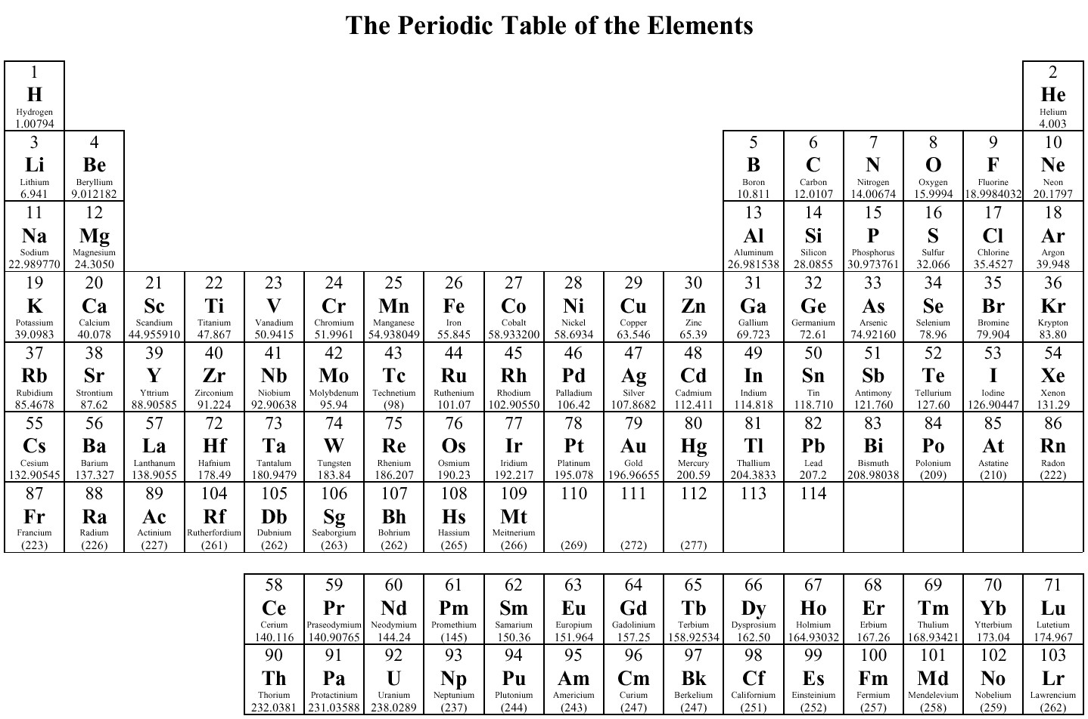
    - Alkali Metals
    - Alkaline Earth Metals
    - Halogens
    - Noble Gases
    - Lanthanide
    - Actinides
    - Transition Metals
    - Metals
    - Nonemtals
    - Metalloids
    - Main Block elements

Periodicity

- Determine which two elements are the most similar and explain why?
- Fe, Al, O, F, Br

- Mg, Si, N, Ba, Kr

- Define electronegativity, ionization energy, atomic radius, and electron affinity:

- Describe electron shielding.

- Using the electron cloud model, explain why the exact size of an atom is difficult to measure.

- Which metal has a larger radius: Li or Na? Why?

Which atom or ion has a larger radius: Li or Li⁺¹? F or F⁻¹? Why?

- Identify ions by their similarity to the electron configurations of noble gases.
S²⁻ = ____ noble gas configuration

Na⁺¹ = = ____ noble gas configuration

- Which of the following elements has the largest atomic radius: B, Al, Ga, or In?

- Which of the following elements has the smallest ionization energy: K, As, N, Se?

- Which of the following elements has the largest electronegativity: K, As, N, Se?

Lab Applications
- Reactivity Lab: Discuss lab observations of trends in reactivity down the groups for metals.

Explain why Group 2 elements are less reactive than Group 1 elements
(consider this question in terms of valence electrons and periodic trends).

- Mendeleev and Alien Periodic Tables: Recognize how to identify unknown elements based on common physical and chemical properties across the periods and down the groups.

