Psychology and the Senses Web quest

Name Date Period

**Go to the website** [**http://www.intropsych.com/ch04_senses/equilibrium.html**](http://www.intropsych.com/ch04_senses/equilibrium.html) **to find all answers. You will need to go to the table of contents when going to a different topic on this web quest.**

**Balance-**

Look at the diagram of the inner ear and label the parts of the ear. Also, read further and describe the function of each part. Do the same for the eye and the auditory system.

The Inner Ear

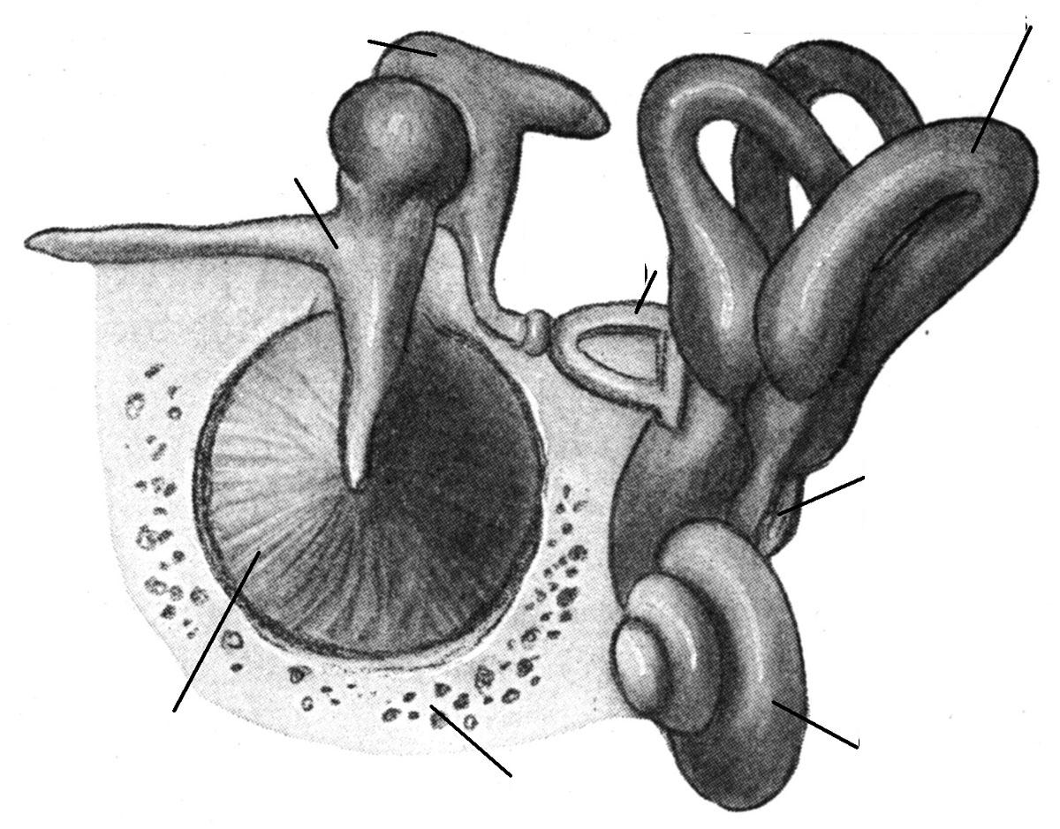

The vestibular system consists of:

Who discovered the vestibular system and how?

Read “Musical Hallucinations in Deafness” and explain what that is and what causes it.

Read “Color Vision” and explain Isaac Newton’s experiment.

Read “Theories of Color Vision” and describe the different theories.

Go to “From Sensation to Perception” and explain how one goes to the other. Then go to the next page and describe how hallucinations, illusions, and perceptions are connected.

Go to the table of contents and click on “The Theory of Signal Detection” and describe the theory.

Read through Part Five- Extra Sensory Perception and write down any interesting facts.

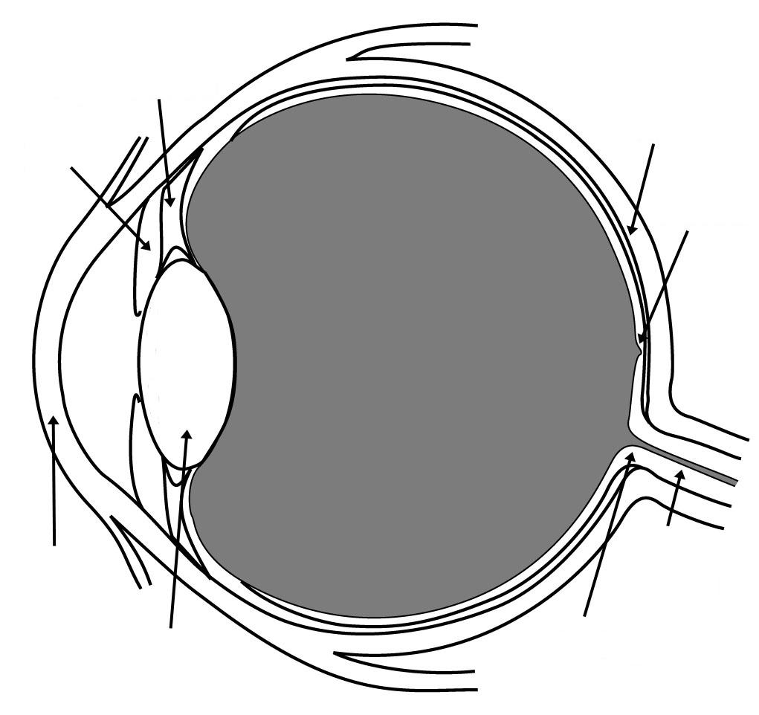

THE EYE- Perceptions

The Auditory System- Sound

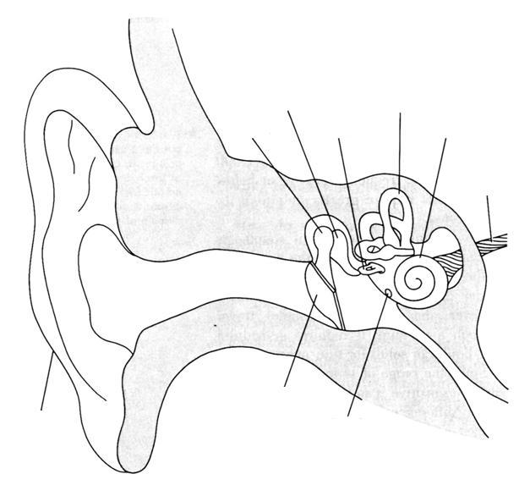

Go to <http://faculty.washington.edu/chudler/nsdivide.html> and take notes on the breakdown of the nervous system.

Go to <http://faculty.washington.edu/chudler/lobe.html> and write down the lobes of the brain and their sensory responsibilities.