Contact: Steven Swensen  Windsor Locks  High School  Phone 860-292-5713  Fax 860-292-5039  sswensen@wlps.org | 58 S. Elm St.  Windsor Locks, CT 06096 | Windsor Locks  High School

Press Release

Windsor Locks High School Student

Rotary Youth Leadership
Windsor Locks, CT December 11, 2015:

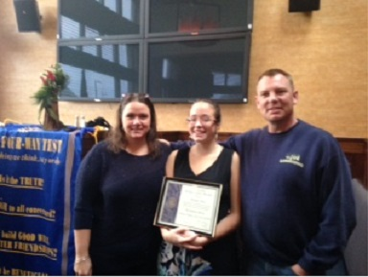
WLHS is proud of this month's recipient of the Rotary Student of the Month Award. Briana Hall, a junior at WLHS, was honored recently for her outstanding participation and contributions to the Windsor Locks community. Not only is Briana an exceptional student, but her attention to civic and social responsibilities exceeds the standard. Briana is actively involved in Unified P.E. and Peer Leadership. She single-handedly raised over 25% of the funds raised for Breast Cancer Awareness last month. A conscientious student, Briana always goes above and beyond to help her peers and her teachers in any way that she can.

