

Important Events in the School Counseling Department

**Friday, December 4th: Second quarter progress reports will be distributed to students. If you have questions, please feel free to contact your student’s teachers directly by email at wlps.org. Parents are also encouraged to check the PowerSchool “parent portal” regularly, to stay informed as to their student’s academic progress!**

**Freshmen, Sophomores & Juniors: All of these grades sat for the newly designed PSATs on October 14, 2015. Scores for these tests will be available sometime this month.**  **It is important for Gr. 9-11 students to go to sat.collegeboard.org to make an account so that they can see their scores and get resources to help them as they move toward taking the newly designed SATs. If you have questions, please touch base with your school counselor.**

**Seniors: Please make sure you are checking in with your school counselor to finalize your college and career plans**. You need to make sure that you are submitting applications for the appropriate deadlines, whether for 2-year, 4-year, or technical schools. **Many colleges have a January 1st, 15th, or February 1st** deadline so it is important to finalize all your material in Common App and Naviance before the Holiday Break!!

**Seniors should also be checking for Scholarship Information on Naviance, or go to** [**www.fastweb.com**](http://www.fastweb.com) **for more National Scholarships. In February more information will be available for Dollars for Scholars – Stay tuned!**

**Juniors:** On December 8th, the school counselors will be meeting with juniors during Advisory in designated areas by counselor to begin the college and career planning process. Students will be given a resource guide which will assist in the planning process. **The school counselors will also host a Junior Parent Planning Meeting on Wednesday, December 9th at 6pm in Media.**

* December 1st – Financial Aid Eve

Media Center – 6pm

* December 2nd – ASVAB Testing

8:15am

* December 5th – SAT testing –

Not at WLHS

* December 8th – Juniors to meet

with their individual counselors

during Advisory for a lesson

regarding Post-secondary Planning

* December 9th – Junior Parent Post

Secondary Planning Evening –

Media Center – 6pm

* December 12th – ACT testing

Not at WLHS

*December – Date TBD – PSAT

results available online

* December 24- January 3rd –

Holiday Break

Important events and

Dates

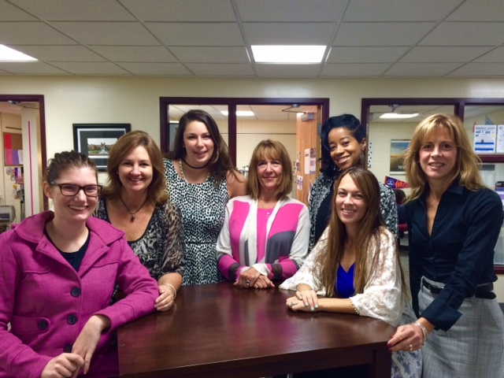

December

2015

­

58 South Elm Street

Windsor Locks, CT 06096

860-292-5032 Office • 860-292-5039 Fax

www.wlps.org/WLHS/

Windsor Locks High School Counseling Commentaries

**­**

Windsor Locks High School

**ASVAB – Scheduled for December 2, 2015**

Windsor Locks HS will be offering the Armed Services Vocational Aptitude Battery (ASVAB) to interested seniors and juniors on Dec. 2ND at 8:15am. The ASVAB consists of assessments designed to classify a person’s aptitudes as they relate to occupational training. This is a valuable diagnostic test for students who are looking for some sort of helpful feedback on skills and possible career options. The ASVAB has **NO** direct connection to the actual registration of students into the Armed Services. If interested in this career exploration opportunity, please see Mrs. Nelson in the school counseling office to sign up.

**College Goal Sunday**

**This annual event is designed to assist prospective college students and their families in completing the Free Application for Federal Student Aid (FAFSA). Financial aid professionals and hundreds of volunteers offer free hands-on assistance. The goal of College Goal Sunday is to make sure that the process of applying for college financial aid is not an obstacle in attending any post-secondary program. College Goal Sunday is scheduled from 1-4 p.m. at several different locations in Connecticut. On January 24th assistance on FAFSA can be done at Windsor High School and on January 30th, Manchester Community College will host this event. Please visit the website at http://www.collegegoalsundayct.org/ for more information, including locations.**



important events continued

financial aid evening

december 1st

**Attention Junior and Senior Parents:**

**On Tuesday, December 1st at 6pm in the Media Center, the School Counseling Department will be hosting a Financial Aid Evening for senior parents preparing to apply for financial aid and for junior parents who want to know more about the process ahead of them.**

**Carolyn Karno of Educational Funding Strategies will be our presenter for the evening. Carolyn is a** **seasoned financial aid professional with a wide range of higher education experience.  Before starting her own consulting business, she was the Manager of College Planning and Financial Aid at the Connecticut Student Loan Foundation. She has been working with school counselors and families for several years providing college planning and financial aid workshops.**

December

2015

***A Professional Learning Community***

***Committed to Excellence***



***“Life isn't about finding yourself. Life is about creating yourself.”***

[George Bernard Shaw](http://www.brainyquote.com/quotes/authors/g/george_bernard_shaw.html)

**The Windsor Locks High School Counseling staff would like to extend our wishes to all for a Happy, Healthy, and Safe Holiday Season!!!**

**Wishing you all a very Happy New Year as well!**



december

2015

­

**Deborrah Ramirez – Director** 860-292-5725 [dramirez@wlps.org](mailto:dramirez@wlps.org)

**Last names: S-Z**

**Kristen Smith – Counselor** 860-292-5739 [ksmith@wlps.org](mailto:ksmith@wlps.org)

**Last names: A-G**

**Antoinette Grant – Counselor** 860-292-5748 [agrant@wlps.og](mailto:agrant@wlps.og)

**Last names: H-R**

**Allison Nelson –**

**Transition Coordinator** 860-292-5881 [anelson@wlps.org](mailto:anelson@wlps.org)

**Emily Owens – Psychologist** 860-292-5726 [eowens@wlps.org](mailto:eowens@wlps.org)

**Jeanne Russo – Social Worker** 860-292-5718 [jrusso@wlps.org](mailto:jrusso@wlps.org)

**Jodi Zaine - Secretary** 860-292-5717 [jzaine@wlps.org](mailto:jzaine@wlps.org)

pathways @ Windsor Locks

*Make an appointment with Mrs. Nelson in Guidance and let her help you discover what's next after you graduate from Windsor Locks!*

**Students looking for Community Service Opportunities, please view the bulletin board outside guidance. Mrs. Allison Nelson, our Transitions/Pathways Coordinator is also a valuable resource in assisting students with community service options.**

**Students need 20 hours of Community Service as part of their graduation requirements. The sooner those hours are logged in the better. Additionally, there are great scholarships given for community service both by colleges and through our Dollars for Scholars Program – so get out there and serve your community!!**

*Mrs. Nelson, Transitions/Pathways Coordinator*

Windsor Locks HS Counseling Department

Write captions for the selected photos.