|  |  |  |
| --- | --- | --- |
| Contact: Steven Swensen  Windsor Locks  High School  Phone 860-292-5713  Fax 860-292-5039  [sswensen@wlps.org](mailto:sswensen@wlps.org) | 58 S. Elm St.  Windsor Locks, CT 06096 | Windsor Locks  High School |

Press Release

# **Windsor Locks High School Student**

# **Rotary Student of the Month**

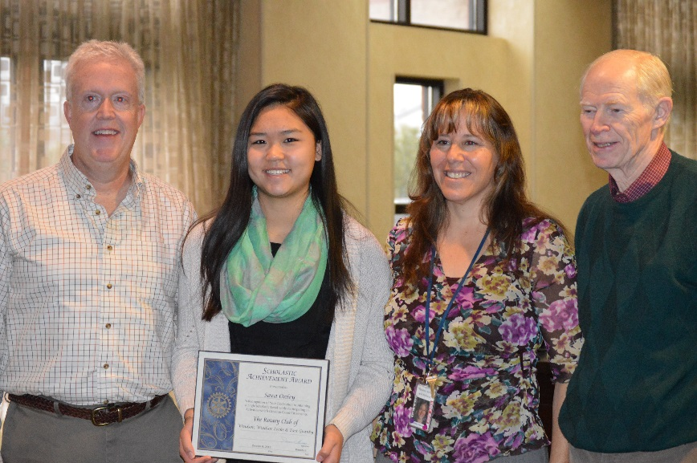Windsor Locks, CT November 12, 2015:

Sara Onley was awarded the Rotary Student of the Month award on 11/12/15.  A breakfast was held in her honor.  Rotary Student of the Month award recipients are students who exemplify high ethical standards, who help build goodwill and peace and who act as humanitarians throughout their daily lives.   Sara was an easy choice for this award!