*Copper One Tube Reaction*

**Learning Target:**

I can distinguish between physical and chemical changes occurring in a mixture of chemicals.

**Lab Materials:**

test tube, iron nail, sodium chloride, copper (II) sulfate, distilled water, stir rod, tissue paper

**Pre Lab:**

1. Identify any safety precautions that should be taken while completing this lab:

**Procedure:**

1. Label a test tube with tape to identify your group.
2. Fill approx. 1/3 of the test tube with copper (II) sulfate crystals. Gently tap the tube to allow the crystals to settle.
3. Using a glass stirring rod, carefully cover the crystals with a layer of tissue paper.
4. Slowly, and with as little disturbance as possible, add enough *distilled* water to just cover the paper and blue crystals.
5. Repeat the process for the sodium chloride, filling approx. 1/3 of the test tube. Gently tap the tube to allow the crystals to settle.
6. Push more tissue paper into the test tube on top of the white crystals.
7. Add enough water to cover the tissue paper and white crystals.
8. Obtain an iron nail and expose the surface by rubbing with sand paper.
9. Carefully slide the nail into the test tube.
10. Continue adding water until the nail is completely covered.
11. Cover the test tube with a stopper and record *descriptive* observations daily for 4 days.

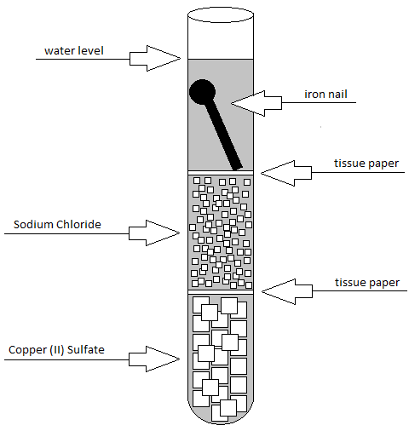

**Conclusion** (*in your lab notebook*)**:**

1. What evidence suggests that a chemical change is occurring in the test tube?
2. Distinguish between the physical and chemical changes.