|  |  |  |
| --- | --- | --- |
| Contact: Steven Swensen  Windsor Locks  High School  Phone 860-292-5713  Fax 860-292-5039  [sswensen@wlps.org](mailto:sswensen@wlps.org) | 58 S. Elm St.  Windsor Locks, CT 06096 | Windsor Locks  High School |

Press Release

# **Windsor Locks High School Student**

# **Rotary Student of the Month**

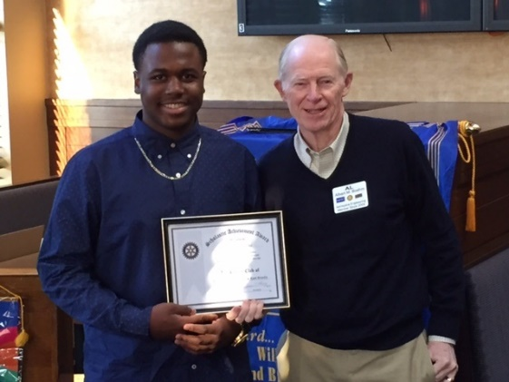Windsor Locks, CT October 8, 2015:

It is with great pleasure that WLHS celebrates the accomplishments and successes of freshman Darrien Stephens. Darrien received the “Rotary Student of the Month” Award on October 8, 2015. According to Darrien’s teachers, “Darrien is a model student: He is a role-model to his peers, a tremendous asset in class, and always goes above and beyond for self, peers, and staff members. Darrien often asks other students if they need assistance, and is always ready and willing to participate in class.” Darrien recently completed the 2-day BRIDGES leadership conference where he shined as a true student leader. His positive interactions with staff and peers, and his thoughtful, insightful contributions helped make the conference more authentic and influential for all participants. The WLHS community is delighted that Darrien has been chosen for this award, and looks forward to his future contributions.

Pictured above: Darien Stephens (WLHS Student) and Albert Boehm (Aerospace Engineer and Rotary Club Member)