|  |  |  |
| --- | --- | --- |
| Contact: Steven Swensen  Windsor Locks  High School  Phone 860-292-5713  Fax 860-292-5039  [sswensen@wlps.org](mailto:sswensen@wlps.org) | 58 S. Elm St.  Windsor Locks, CT 06096 | Windsor Locks  High School |

Press Release

# **Windsor Locks High School Student**

# **Habits of Scholarship**

Windsor Locks, CT February 12, 2016:

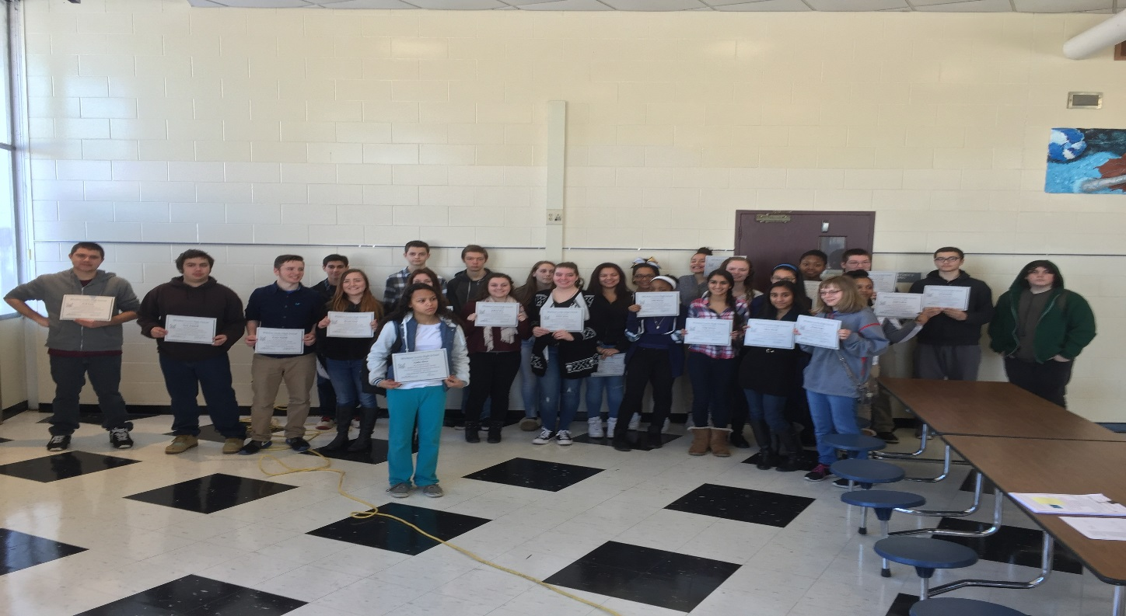

Windsor Locks High School had a breakfast this Friday morning (02/12/2016) to celebrate 30 students for their achievements in Habits of Scholarship. Habits of Scholarship are used as a measure to inspire students in the academic and personal characteristics that are necessary for them to achieve their goals and be good citizens.

The breakfast was not only attended by the students, but by their families, as well as high school staff, administration and the superintendent, Dr. Susan Bell.

The Dean of Students, Mr. Michael Lefevre, gave an opening address that touched directly on the ideas of growth as a person and student that the habits of scholarship are meant to enhance.

He said:

“I love to look up at the stars at night. How many of you love to do that? I do. And I’m convinced that the more you know about the truth of the universe, the more you want to stare and wonder. For those who look up and simply see fixed points of light, immobile and never changing, I can imagine how unremarkable that perspective is; how easy it might be to stand beneath a cloudless night sky unmoved, with no desire to look up, wonder and reach for them.

But for the rest of us, it is something else entirely. We look up and see beyond the surface, all the way down to the truth where black holes are bending time, stars are roiling in the plasma of nuclear fusion and the first light of creation is still racing away from the point of its birth into a blackness the nature of which we can’t begin to conceive. It is changing, pulsing and growing into something that is fraught with meaning, and remarkable.

This second vision is the reflection of our deep belief in the growth mindset and it is one of the things we celebrate in each of your children today: their capacity to not see themselves as fixed points in a seemingly colorless sky, but their belief in their own capacity to grow and change, to become something better tomorrow than they were today. More knowledgeable, more sensitive, more determined, a harder worker, a stronger person, a genuine scholar.”

The school is happy to celebrate with these students and their families for their achievement.

The students honored today were: Sean Buenaventura, Jordyn Carey, Brandon Cooley, Anna Dombroski, Nicolas Duquette, Connor George, Sureaya Inusah, Victoria Lingua, Noah Logan, Hannah Lowry, Dominick Maille, Destiny Maldonado, James Marinone, Kaylie Morris, Afnan Munshi, Esther Nguyen, Domanic Novak, Ashley O’Brien, Randi Parkman, Travis Pedemonti, James Pequita, Velda Ramsey, Cinthia Rivera, Tejay Samba, Jewly Santiago, Tanya Sharma, Genesis Stevenson, Kristina Taylor, Chad Varkal, Connor Zawasky