**Reconstruction: Success or Failure?**

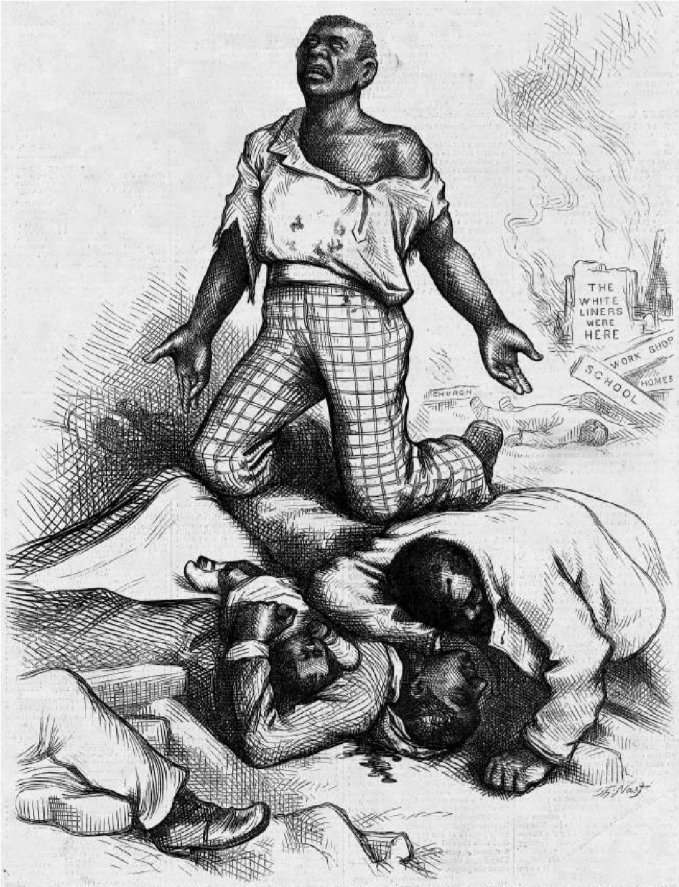

“Is

*This*

a Republican

Form of Government?

Is

*This*

Protecting Life,

Liberty, or Property?”



*Harper’s Weekly*

September 1, 1868

Overview:The twelve years after the Civil War proved to be a difficult time for America. Called Reconstruction by historians, this era saw an increase of freedom for former slaves. However, there was also great resistance to change. In 1877 attempts to reconstruct the South officially ended. How successful was the attempt to reconstruct the South after the Civil War?

Directions: Read the background information and all provided documents.

Write a essay that answers the essential question below. Be sure to create a strong **claim/thesis** (what you will prove) and use **cited evidence** from the documents to support your claim. (You may use the documents in any order you choose, they do NOT need to be used in the order presented-use source information provided). Follow the attached Argument Essay Rubric to guide your writing.

**Essential Question: To what extent was the Reconstruction of the South successful? To what extent was it a failure socially, economically, and politically?**

**BACKGROUND**

The process of reconstructing the Union began in 1863, two years before the Confederacy formally surrendered. After major Union victories at Gettysburg and Vicksburg, Abraham Lincoln issued the Proclamation of Amnesty and Reconstruction in which he outlined his Ten-Percent Plan. The plan stipulated that each secessionist state had to redraft its constitution and could reenter the

Union only after 10 percent of its eligible voters pledged an oath of allegiance to the United States.

Many Radical Republicans believed that Lincoln’s plan was too lenient: they wanted to punish the South for secession from the Union, transform southern society, and safeguard the rights of former slaves. As an alternative to the Ten-Percent Plan, Radical Republicans and their moderate Republican allies passed the Wade-Davis Bill in 1864. Under the bill, states could be readmitted to the Union only after *50* percent of voters took an oath of allegiance to the Union. Lincoln pocket-vetoed the bill, however, effectively killing it by refusing to sign it before Congress went into recess. Congress did successfully create the Freedmen’s Bureau, which helped distribute food, supplies, and land to the new population of freed slaves.

On April 14, 1865, John Wilkes Booth assassinated President Lincoln in Ford’s Theatre in Washington, D.C., and Vice President Andrew Johnson became president. Presidential Reconstruction under Johnson readmitted the southern states using Lincoln’s Ten-Percent Plan and granted all southerners full pardons, including thousands of wealthy planters and former Confederate officials. Johnson also ordered the Freedmen’s Bureau to return all confiscated lands to their original owners. While Congress was in recess, Johnson approved new state constitutions for secessionist states—many written by ex-Confederate officials—and declared Reconstruction complete in December 1865.

Although Johnson vetoed Congress’s attempt to renew the charter of the Freedmen’s Bureau in 1866, Congress was successful in overriding Johnson’s veto on its second try, and the bureau’s charter was renewed. They also passed the Civil Rights Act of 1866 , which granted newly emancipated blacks the right to sue, the right to serve on juries, and several other legal rights. Although Johnson vetoed this bill as well, Congress was able to muster enough votes to override it. The Radical Republicans also passed the Thirteenth Amendment, which abolished slavery, and the Fourteenth Amendment, which made freed slaves U.S. citizens.

Many southerners reacted violently to the passage by Congress of the Civil Rights Act of 1866 and the two amendments. White supremacists in Tennessee formed the Ku Klux Klan, a secret organization meant to terrorize southern blacks and “keep them in their place.” Race riots and mass murders of former slaves occurred in Memphis and New Orleans that same year.

Johnson blamed Congress for the violence and went on what he called a “Swing Around the Circle,” touring the country to speak out against Republicans and encourage voters to elect Democrats to Congress. However, many of Johnson’s speeches were so abrasive—and even racist—that he ended up convincing more people to vote *against* his party in the midterm elections of 1866.

The Congress that convened in 1867, which was far more radical than the previous one, wasted no time executing its own plan for the Radical Reconstruction of the South. The First Reconstruction Act in 1867 divided the South into five conquered districts, each of which would be governed by the U.S. military until a new government was established. Republicans also specified that states would have to enfranchise former slaves before readmission to the Union. To enforce this order, Congress passed the Second Reconstruction Act, putting the military in charge of southern voter registration. They also passed the Fifteenth Amendment, giving all American men—including former slaves—the right to vote.

In an effort to limit Johnson’s executive powers, Congress passed the Tenure of Office Act in 1867, which required the president to consult with the House and Senate before removing any congressionally appointed cabinet members. Radicals took this measure in an attempt to protect Secretary of War Edwin M. Stanton, a carryover from Lincoln’s cabinet and a crucial figure in military

Reconstruction. When Johnson ignored the Tenure of Office Act and fired Stanton, Republicans in the House impeached him by a vote of 126–47. After a tense trial, the Senate voted to acquit the president by a margin of only one vote.

Despite sweeping rights legislation by Radical Republicans in Congress, southern whites did everything in their power to limit the rights of their former slaves. During Presidential Reconstruction, white supremacist Congressmen passed a series of laws called the black codes, which denied blacks the right to make contracts, testify against whites, marry white women, be unemployed, and even loiter in public places. Violence by the Ku Klux Klan became so common that Congress had to pass the Ku Klux Klan Act in 1871 to authorize military protection for blacks.

Countless carpetbaggers (northerners who moved to the South after the war) and scalawags (white Unionists and Republicans in the South) flocked to the South during Reconstruction and exerted significant influence there. Although in many respects they achieved their goals of modernizing and Republicanizing the South, they eventually were driven out by Democratic state politicians in the mid1870s.

Most former slaves in the South, meanwhile, became sharecroppers during the Reconstruction period, leasing plots of land from their former masters in exchange for a percentage of the crop yield. By 1880, more than 80 percent of southern blacks had become sharecroppers.

To the Radicals’ delight, Johnson finally left the White House in 1868, when Republican Ulysses S. Grant was elected president. Grant’s inexperience, however, proved to be a liability that ultimately ended Radical Reconstruction. Because Grant had difficulty saying no, many of his cabinet posts and appointments ended up being filled by corrupt, incompetent men who were no more than spoils-seekers.

As a result, scandal after scandal rocked Grant’s administration and damaged his reputation. In 1869, reporters uncovered a scheme by millionaires Jim Fisk and Jay Gould to corner the gold market by artificially inflating gold prices. Schuyler Colfax, vice president at the time, was forced to resign for his complicity in the Crédit Mobilier scandal in 1872. The president lost even more credibility during his second term, when his personal secretary helped embezzle millions of dollars from the U.S. Treasury as a member of the Whiskey Ring.

The discovery of new scandals split the Republican Party in 1872, as reform-minded Liberal Republicans broke from the ranks of moderates and radicals. The Liberal Republicans wanted to institute reform, downsize the federal government, and bring a swift end to Reconstruction. They nominated *New York Tribune* editor Horace Greeley as their party’s presidential candidate (he agreed to run on the Democratic Party’s ticket as well). Though already marred by scandal, Grant easily defeated Greeley by more than 200 electoral votes and 700,000 popular votes.

In 1873, the postwar economic bubble in the United States finally burst. Over speculation in the railroad industry, manufacturing, and a flood of Americans taking out bad bank loans slid the economy into the worst depression in American history. Millions lost their jobs, and unemployment climbed as high as 15 percent. Many blacks, landless whites, and immigrants from both North and South suffered greatly, demanding relief from the federal government. Republicans, refusing to give in to demands to print more paper money, instead withdrew money from the economy by passing the Resumption Act of 1875 to curb skyrocketing inflation. This power play by Republicans prompted northerners to vote Democrat in the midterm elections of 1876, effectively ending Radical Reconstruction.

By the mid-1870s, Democrats had retaken the South, reseating themselves in southern legislatures by driving blacks and white Unionists away from the polls and employing violence and other unethical tactics to win state elections. Most northerners looked the other way during this period, consumed by their own economic hardships.

In the late 1870s and early 1880s, a conservative Supreme Court also struck down much of the civil rights legislation that Radical Republicans had passed. In the 1873 Slaughterhouse Cases, the Court ruled that the Fourteenth Amendment safeguarded a person’s rights only at a federal level, not at a state level (in rulings ten years later, the court further stipulated that the Fourteenth Amendment prohibited racial discrimination only by the U.S. government, not by individuals). In 1876, the Court ruled in *United States v. Cruikshank* that only states and their courts—not the federal government— could prosecute Ku Klux Klan members under the Ku Klux Klan Act of 1871.

As the election of 1876 approached, Democrats nominated Samuel J. Tilden, a lawyer famous for busting corrupt New York City politician William “Boss” Tweed in 1871. Tilden campaigned for restoration of the Union and an end to government corruption. The Republican Party, on the other hand, chose the virtually unknown Rutherford B. Hayes. Many Northern voters, tired of Reconstruction and hoping for more federal relief because of the depression, voted Democrat. Ultimately, Tilden received 250,000 more popular votes than Hayes, and 184 of the 185 electoral votes needed to become president.

With the election result hanging in the balance, Congress passed the Electoral Count Act in early 1877, creating a fifteen-man commission—eight Republicans and seven Democrats—to recount disputed votes in South Carolina, Louisiana, and Florida. Not surprisingly, the commission determined by an eight-to-seven vote that Republican Rutherford B. Hayes had carried all three states. Resentment and political deadlock threatened to divide the country, but both parties were able to avoid division and strike a deal with the Compromise of 1877. Democrats agreed to concede the presidency to the Republicans in exchange for the complete withdrawal of federal troops from the South. Hayes became president, withdrew the troops, and ended Reconstruction.

Your job is to read the documents that follow and write a five- paragraph argument essay that answers the essential question: To what extent was the Reconstruction Era successful? To what extent was it a failure?

# **Document A**

*...the slave went free; stood a brief moment in the sun; then moved back again toward slavery. -W.E.B. Dubois*

## DOCUMENT B

Amendment 13:

Neither slavery nor involuntary servitude, except as punishment for crime whereof the party shall have been duly convicted, shall exist within the United States, or and place subject to their jurisdiction..... 1865

Amendment 14:

All persons born or naturalized in the United States, and subject to the jurisdiction thereof, are citizens of the United States and of the State wherein they reside. No state shall make or enforce any law which shall abridge the privileges or immunities of citizens of the United States; nor shall any State deprive any person of life, liberty, or property, without due process of law; nor deny to any person within its jurisdiction the equal protection of the laws....1868

Amendment 15:

The right of citizens of the United States to vote shall not be denied or abridged by the United States or by any State on account of race, color, or previous conditions of servitude.......1870

**SOURCE:** *U. S. Constitution*.

## Document C

Source: In the years following the Civil War - throughout the South -state, city, and town governments passed laws to restrict the rights of free African-American men and women. These laws were often called “Black Codes.” The example below of “Black Codes” comes from laws passed in Opelousas, Louisiana immediately after the Civil War.

1. "No negro or freedmen shall be allowed to come within the limits of the town of Opelousas without special permission from his employers. Whoever breaks this law will go to jail and work for two days on the public streets, or pay a fine of five dollars.”

1. “No negro or freedman shall be permitted to rent or keep a house in town under any circumstances. No negro or freedman shall live within the town who does not work for some white person or former owner.”

1. “No public meetings of negroes or freedmen shall be allowed within the town.”

1. “No freedman shall be allowed to carry firearms, or any kind of weapons. No freedman shall sell or exchange any article of merchandise within the limits of Opelousas without permission in writing from his employer.”

1. “Every negro is to be in the service of (work for) some white person, or former owner.”

**QUESTION TO THINK ABOUT**-(THE ANSWERS DO NOT NEED TO BE WRITTEN BELOW). Include the ideas in your essay.

Document Analysis : How did black codes restrict the freedom of freedmen?

Document D

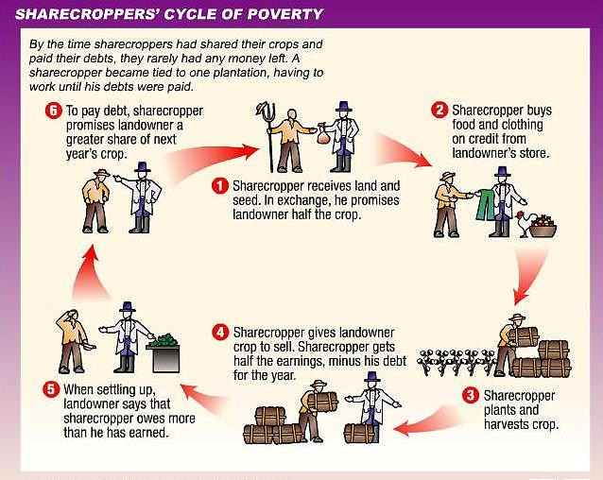Document Analysis

Based on document D and your knowledge of U.S. history, what was the real end result of sharecropping?

Document E

Source: Albion Tourgee, Letter on Ku Klux Klan Activities. New York Tribune, May 1870.

Note: *Tourgee was a white, Northern soldier who settled in North Carolina after the War. He served as a judge during Reconstruction and wrote this letter to the North Carolina Republican Senator, Joseph Carter Abbott.*

|  |  |
| --- | --- |
| It is my mournful duty to inform you that our friend John W. Stephens, State Senator from Caswell, is dead. He was foully murdered by the Ku-Klux in the Grand Jury room of the Court House on Saturday… He was stabbed five or six times, and then hanged on a hook in the Grand Jury room… Another brave, honest  Republican citizen has met his fate at the hands of these fiends…  I have very little doubt that I shall be one of the next victims. My steps have been dogged for months, and only a good opportunity has been wanting to secure to me the fate which Stephens has just met… I say to you plainly that any member of Congress who, especially if from the South, does not support, advocate, and urge immediate, active, and thorough measures to put an end to these outrages…is a coward, a traitor, or a fool. | |
| **Document F**  Source: Independent  Monitor, September 1, 1868. | 6 |

**Document Analysis E and F**

**QUESTIONS TO THINK ABOUT**- Include the ideas in your essay.

* What group(s) is the KKK threatening?
* According to Tourgee, what types of people are being attacked by the KKK? Why would the KKK attack these people?
* How do these documents help answer the DBQ question?

**Document G**

Source: Abram Colby, testimony to a joint House and Senate Committee in 1872.

Note: Colby was a former slave who was elected to the Georgia State legislature during Reconstruction.

**Colby:** On the 29th of October 1869, [the Klansmen] broke my door open, took me out of bed, took me to the woods and whipped me three hours or more and left me for dead. They said to me, "Do you think you will ever vote another damned Radical ticket?" I said, "If there was an election tomorrow, I would vote the Radical ticket." They set in and whipped me a thousand licks more, with sticks and straps that had buckles on the ends of them.

**Question:** What is the character of those men who were engaged in whipping you?

**Colby:** Some are first-class men in our town. One is a lawyer, one a doctor, and some are farmers… They said I had voted for Grant and had carried the Negroes against them. About two days before they whipped me they offered me $5,000 to go with them and said they would pay me $2,500 in cash if I would let another man go to the legislature in my place. I told them that I would not do it if they would give me all the county was worth… No man can make a free speech in my county. I do not believe it can be done anywhere in Georgia.

Document

H

Source:

Harper’s Weekly,

October 21, 1876.

Caption: “Of Course he wants to

vote the Democratic ticket.”

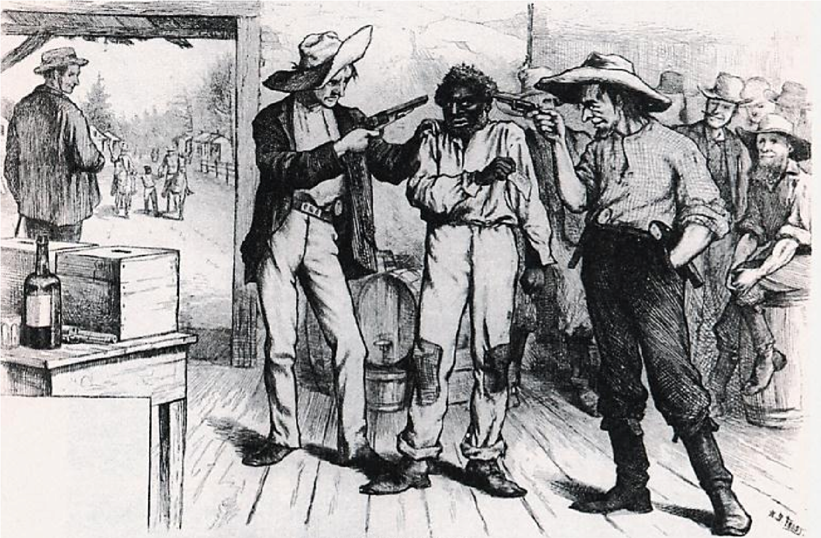

**QUESTIONS TO THINK ABOUT- Include the ideas in your essay.**

**Document Analysis-G and H**

* Why did the KKK attack Abram Colby? According to Colby, what types of people make up the KKK?
* What seems to be the ultimate goal of the KKK?
* What is the main idea of the cartoon?

Document I

Source: Gerald Danzer et al., *The Americans*, McDougall Littell, 1998.

...in the 1870s, Northern voters grew indifferent to events in the South. Weary of the 'Negro Question' and 'sick of carpet-bag' government, many Northern voters shifted their attention to such national concerns as the Panic of 1873 and corruption in Grant's administration....Although political violence continued in the South... the tide of public opinion in the North began to turn against Reconstruction policies.

Document J

Source: Kenneth Stampp, *The Era of Reconstruction, 1865-1877*, Vintage, 1967.

Meanwhile southern Democrats gained strength when Congress finally removed the political disabilities from most of the prewar leadership. In May 1872, because of pressure from the Liberal Republican, Congress passed a general amnesty act which restored the right of office holding [and voting] to the vast majority of those who had been disqualified…After the passage of this act only a few hundred exConfederates remained unpardoned.

**QUESTIONS TO THINK ABOUT**  **Include the ideas in your essay.**

**Document Analysis- I and J**

* Why might increased anger about the corruption in government lead to less interest in government attempts to reconstruct the South?
* How did the restoration of voting rights to white Southerners undermine efforts to preserve and protect the voting rights of the freedmen?

**Document K**

Source: Heather Cox Richardson, *The Death of Reconstruction: Race, Labor and Politics in the Post-Civil War North, 1865-1901*. Harvard University Press, Cambridge, Massachusetts, 2001.

In the fall of 1873, even the staunchly (firmly) pro-Grant and pro-freedman Boston Evening Transcript ran a letter ... arguing that "the blacks, as a people, are unfitted for the proper exercise of political duties.... The rising generation of ... blacks needed a period of probation and instruction; a period ... long enough for the black to have forgotten something of his condition as a slave and learned much of the true method of gaining honorable subsistence and of performing the duties of any position to which he might aspire.

Document

L

Northern artist’s portrayal of the

South Carolina State Legisla

ture

during Reconstruction.

Source:

The Cover of Harper’s

Weekly, March 14, 1874

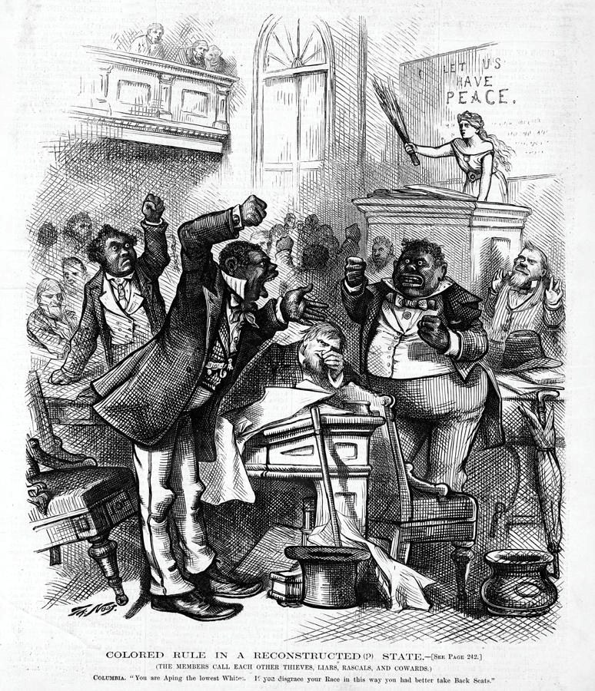

**QUESTIONS TO THINK ABOUT- Include the ideas in your essay. Document Analysis K and L**

* According to the letter from the Boston Evening Transcript, why did some people believe blacks were unfit to be government officials? How does this letter show racism existed in the North?
* How do this cartoon & letter help explain why Northerners lost interest in Reconstruction?
* How does the image above depict black politicians in the South?

## Document M

Source: The Freedmen of Edisto Island Petition to the Commissioner of the Freedmen’s Bureau and to the President for the Opportunity to Obtain Their Own Land, Edisto Island, S.C. October 1865.

General:

We want Homesteads; we were promised Homesteads by the government. If it does not carry out the promises Its agents made to us,…we are left In a more unpleasant condition than out former. We are at the mercy of those who are combined to prevent us from getting land enough to lay our Fathers bones upon… To the President of these United States:

Shall not we who Are freedman and have been always true to this Union have the same rights as are enjoyed by Others?... Are not our rights as A free people and good citizens of these United States To be considered before the rights of those who were Found in rebellion against this good and just government (and now being conquered) come (as they Seem) with penitent hearts and beg forgiveness For past offenses and also ask if their [sic] lands Cannot be restored to them. Are these rebellious Spirits to be reinstated in their [sic] possessions And we who have been abused and oppressed For many long years not be allowed the Privilege of purchasing land But be subject To the will of these large Land owners? God forbid…

Unless some provision is Made our future is sad to look upon…We therefore look to you In this trying hour as A true friend of the poor and Neglected race, for protection and Equal Rights, with the privilege of purchasing a Homestead- A Homestead right here in the heart of South Carolina.

## Document N

Source: Thomas Nast in Harper’s Weekly, October 24, 1874.

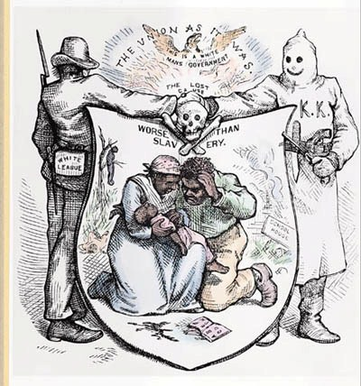

**Document O**

The Colored Member Admitted to His Seat in the Senate

An Interesting Scene When the Oath was Administered

HIS PLACE ON THE REPUBLICAN SIDE

Special Dispatch to The New York Times

Washington, Feb. 25, 1870 -- Mr. Revels, the colored Senator from

Mississippi, was sworn in and admitted to his seat this afternoon at 4:40 OTHER HEADLINES o'clock. There was not an inch of standing or sitting room in the galleries, so

**Debate in the House on** densely were they packed; and to say that the interest was intense gives but a faint idea of the feeling which prevailed throughout the entire proceeding. Mr. **the Indian Question**Vickers, of Maryland, opened the debate to-day, arguing against the admission, **General Sheridan** on the ground that Revels had not been a citizen for nine years [since he had **Harshly Criticized** been a slave until 1865], and therefore was not eligible..