Metal Activity Series Lab
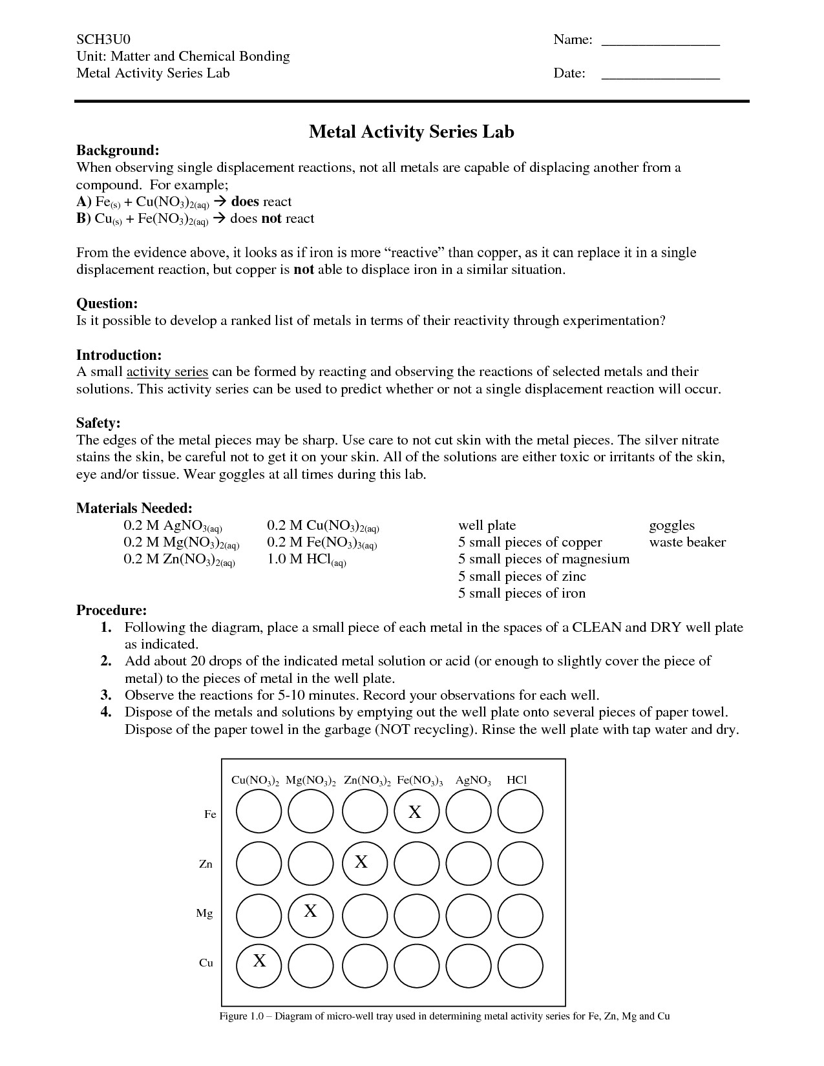

Data Table:
 | Cu(NO₃)₂ | Mg(NO₃)₂ | Zn(NO₃)₂ | Fe(NO₃)₃ | AgNO₃ | HCl
Fe
Zn
Mg
Cu
Based on your observations, construct an activity series by ranking the reactivity of each metal. The most active metal should be at the top and the least active metal on the bottom of the activity series.

most reactive

least reactive

- Describe how you reasoned through the arrangement of your activity series:

- Define an activity series:

- What is the rule for predicting if a single replacement reaction will occur?

- How are activity series created?

- Write a balanced equation for the reaction if Aluminum and Copper (II) chloride react to form copper metal and aluminum chloride.

- Will the reaction of Aluminum and Copper (II) chloride occur? Explain.

- How does your reactivity series compare to an actual reactivity series?

- How could you improve the experiment to be more accurate?

- Research the difference between the metal cans that contain coffee versus acidic tomatoes. Why do tomato cans contain a lining?

