Ch 6 Review Answers

- Summarize the differences and similarities between ionic and covalent bonds:
- Ionic = “give” / “take” electrons – oppositely charged ions (a positive cation and negative anion) are bonded together because a more electronegative atom pulls electrons towards itself and both ions are stable and have full octets.
- Covalent compounds share electrons (either equally = non polar or not equally = polar) in order to achieve full octets.
- Ionic compounds form between a metal (cation) and nonmetal (anion), whereas covalent compounds are two nonmetals joined together.
- Ionic compounds are arranged in a crystal lattice, composed of alternating +/- ions. This structure is very stable, and therefore requires a lot of energy to break apart, hence high melting and boiling points. Ionic compounds conduct electricity only as liquids (molten) or when dissolved because the ions and electricity do not move in a solid state.
- Covalent compounds on the other hand have a weaker attraction to one another (intermolecular forces are very weak). So covalent compounds tend to be softer solids or liquids and gases. Since the structure is not as stable, covalent compounds have lower melting and boiling points. Ions are not involved in covalent

- Identify each compound as ionic (I) or covalent (C) and write the formula:

  - Diphosphorous pentoxide I or C P₂O₅
  - strontium chloride I or C SrCl₂
  - Carbon tetrachloride I or C CCl₄
  - Ammonium nitrate I or C NH₄NO₃

- Identify each compound as ionic (I) or covalent (C) and name each compound:

  - KOH I or C potassium hydroxide
  - CO₂ I or C carbon dioxide
  - SO₃ I or C sulfur trioxide
  - MgSO₄ I or C magnesium sulfate

- Classify the bond using electronegativity differences:
  - O-H 3.5-2.1 = 1.4 polar covalent
  - Li-F 4.0 – 1.0 = 3.0 ionic
  - S-Cl 3.0-2.6 = 0.4 nonpolar covalent
  - N-O 3.5 – 2.0 = 0.5 polar covalent

- Draw Lewis Structures for the following molecules:

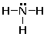
NH₃

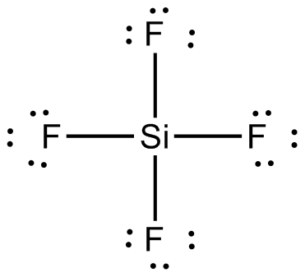
SiF₄

SO₂ 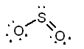

HCN 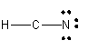

- Complete the VSEPR table:

 | Lewis Dot Structure | Shape | Bond Angles | Ball and Stick model | Polar or Nonpolar?
CH₂F₂ | 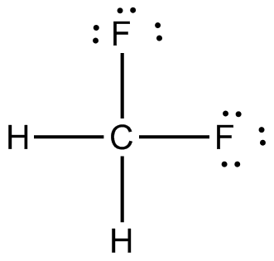 | Tetrahedral | 109.5 | 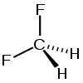 | Polar  (asymmetrical)
PCl₃ | 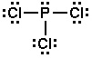 | Trigonal pyramidal | <109.5 |  | Polar  (lone pairs on central atom)
OF₂ | 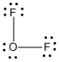 | Bent | <109.5 | 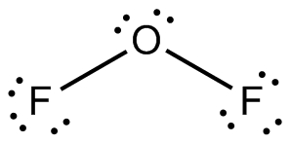 | Polar  (lone pairs on central atom)

- Classify the type of IMF (intermolecular force) associated with each molecule:
Molecule: | AlH₃ | HF | CH₄
IMF: | Dipole-Dipole | Hydrogen Bonding | LDF

