Molecular Geometry Report Sheet
Molecular formula | Lewis structure | # Atoms Bonded to Central Atom | # Lone Pairs on Central Atom | VSEPR Drawing | Shape | Angle
CH₄ |  | 4 | 0 | 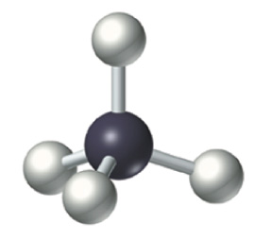 | Tetrahedral | 109.5
SiF₄
PF₃
CCl₄
SH₆
Molecular formula | Lewis structure | # Atoms Bonded to Central Atom | # Lone Pairs on Central Atom | VSEPR Drawing | Shape | Angle
CH₄ |  | 4 | 0 |  | Tetrahedral | 109.5
H₂O
SCl₂
I₃⁻
SO₂
Molecular formula | Lewis structure | # Atoms Bonded to Central Atom | # Lone Pairs on Central Atom | VSEPR Drawing | Shape | Angle
ICl₄⁻
AsF₅
IF₄⁺
H₃O⁺
TeF₅⁻
Molecular formula | Lewis structure | # Atoms Bonded to Central Atom | # Lone Pairs on Central Atom | VSEPR Drawing | Shape | Angle
CH₄ |  | 4 | 0 |  | Tetrahedral | 109.5
IOF₅
BrF₃
SO₄²⁻
CO₃²⁻
Molecular formula | Lewis structure | # Atoms Bonded to Central Atom | # Lone Pairs on Central Atom | VSEPR Drawing | Shape | Angle
CH₄ |  | 4 | 0 |  | Tetrahedral | 109.5
NH₃
HCN
ICl₄⁻
PI₅
Molecular formula | Lewis structure | # Atoms Bonded to Central Atom | # Lone Pairs on Central Atom | VSEPR Drawing | Shape | Angle
CH₄ |  | 4 | 0 |  | Tetrahedral | 109.5
SeCl₂
BH₃
SiS₂
SF₆
Molecular formula | Lewis structure | # Atoms Bonded to Central Atom | # Lone Pairs on Central Atom | VSEPR Drawing | Shape | Angle
CH₄ |  | 4 | 0 |  | Tetrahedral | 109.5
SiH₄
PH₃
CH₃F
CO₃²⁻

