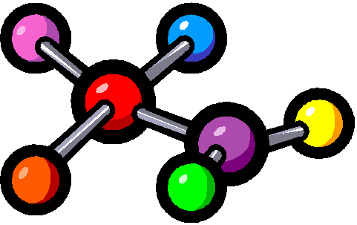
VSEPR Molecular Models Lab

Objective: To predict structure and polarity of a molecule based on its Lewis Dot structure and VSEPR Theory.
Materials: molecular model kit. Colored pencils, periodic table, VSEPR & Molecular Geometry handout, notes
Procedure: Determine the molecular geometry of the molecules below, build, sketch and label the model and complete the chart.

# | Molecule | Lewis Diagram | # bond pairs  # lone pairs | Type of  Molecule  (AB₃, etc) | Molecular Shape  & Bond Angle | Sketch of Model | Hybridization of central atom
1 | H₂S |  | #B=  #L=
2 | H₂CO |  | #B=  #L=
3 | CH₄ |  | #B=  #L=
4 | NH₃ |  | #B=  #L=
5 | Cl₂ |  | #B=  #L=
# | Molecule | Lewis Diagram | # bond pairs  # lone pairs | Type of  Molecule  (AB₃, etc) | Molecular Shape  & Bond Angle | Sketch of Model | Hybridization of central atom
6 | BF₃ |  | #B=  #L=
7 | PBr₅ |  | #B=  #L=
8 | O₃ |  | #B=  #L=
9 | CO₂ |  | #B=  #L=
10 | CH₃Cl |  | #B=  #L=

