Why do ions want to be isoelectronic with a nearby noble gas?  How is the rule used to determine the charges of main group elements? (pg 158-161) | Describe the arrangement of ions in a salt.  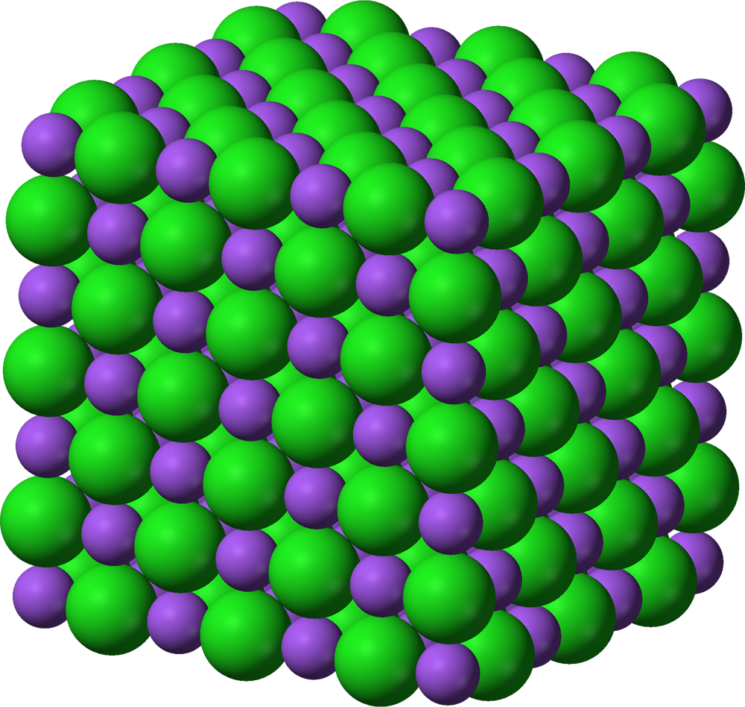 | How does the arrangement of ions in a salt affect melting and boiling points?  (pg 173)
Why are salts are hard and brittle.  (pg 172-173) |  | Why do salts conduct electricity as liquids or when dissolved, yet they do not conduct electricity as solids?  (pg 174-175)

