Name: __________________________

Chapter 4 Test Review

You may use a GREEN periodic table on the test… NOT your colorful/ labeled one!

- List the number of valence electrons for each of the following elements:

  - _____ Be
  - _____ Ge
  - _____ O
  - _____ Cl
  - _____ Br
  - _____ Rb
  - _____ He
  - _____ Ar
  - _____ Na
  - _____ Mg

- Write the group number, period number, atomic number, and atomic mass:
Group Period Atomic # Atomic Mass
Kr _____ _____ _____ __________
Sr _____ _____ _____ __________

- State the periodic law:

- Which two elements are the most similar? Explain why:
- Fe, Al, O, F, Br

- Mg, Si, N, Ba, Kr

- Distinguish between the properties of the alkali metals, alkaline earth metals, halogens, and noble gases:

- Distinguish between metals, nonmetals, and metalloids based upon their properties and location on the periodic table.

 | Metals | Nonmetals
physical appearance
conductivity
malleability
reaction with acid
location on PT

metalloids:

- Classify the following as: Metal (M), Metalloid (S for semiconductor), Non-Metal (N)
  - Ge
  - Mn
  - Dull crystal that crushes easily and has a low melting point
  - Ductile substance that reacts with acid
  - Silvery white element that is a conductor of electricity
  - Group 1 element
  - Group 18 element

- Be able to label the following areas on the periodic table (do NOT use a colored reference):

Color the following regions on the periodic table:
Outline the following regions:
    - Metals
    - Nonmetals
    - Metalloids

List the Main Block groups:
_________________

    - Alkali Metals
    - Alkaline Earth Metals
    - Halogens
    - Noble Gases
    - Lanthanide
    - Actinides
    - Transition Metals

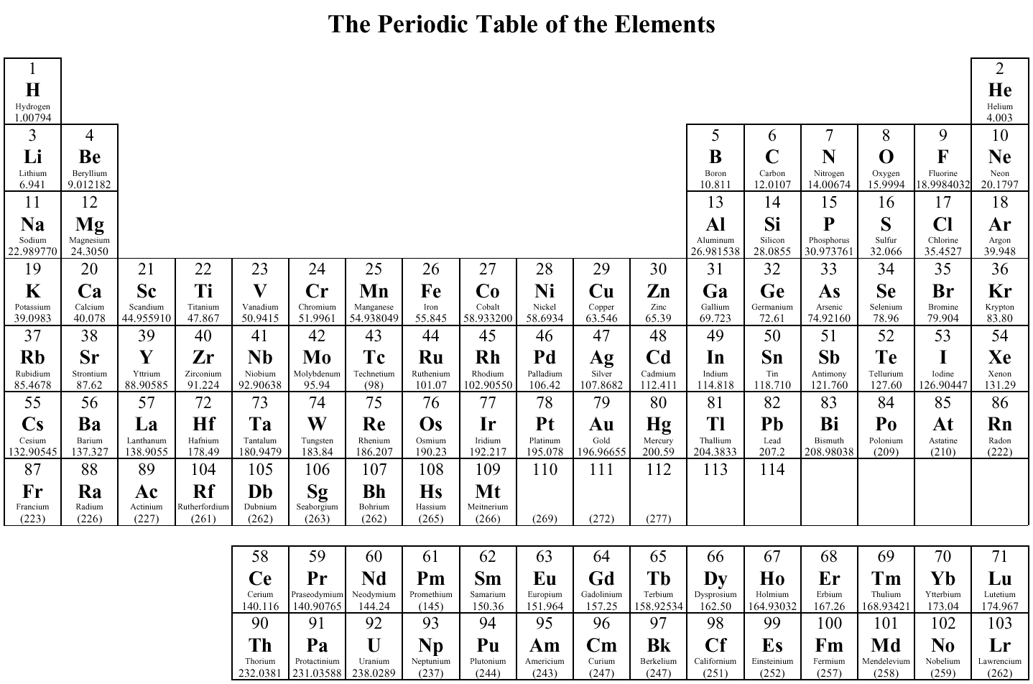

- Describe/ define atomic radius, ionization energy, and electronegativity and know the general trends across the periods and down the groups:

- Be able to rank elements according to increasing/decreasing atomic radius, ionization energy, and electronegativity:

  - B, Be, C, Li, N

increasing atomic radius: _______________________
increasing ionization energy: _______________________
decreasing electronegativity: _______________________

  - Al, B, Ga, In, Tl

decreasing atomic radius: _______________________
decreasing ionization energy: _______________________
increasing electronegativity: _______________________

