Name: __________________________

Chapter 1-3 Test Review Answers
Sig Figs:
- How many significant figures are in the following numbers:
a. 0.003 b. 42.0 c. 15.80
1 3 4
- Write the following answers to the correct number of significant figures:
a. 16.4 x 8 = 131.2 = 100 (rounded to 1 SF)

b. 894 / 34.2 = 26.1403509 = 26.1 (rounded to 3 SF)

c. 37.26 m - 2.7 m = 34.56 = 34.6 (reported to the least precise place value)

- What is the correct measurement with sig figs for the length of the black line?
5.50cm (any number 5.50-5.59 would be correct if reported to the hundredths place)

Vocab:
- Define the following vocab terms: atom, compound, matter, mass, volume, density, accuracy, precision, isotope
Atom: the basic unit of matter
Compound: a substance composed of two of more elements
Matter: anything that has mass and volume
Mass: the quantity of matter in an object
Volume: the space an object occupies
Density: mass / volume
Accuracy: results are close the actual/accepted value
Precision: results are close to one another

History of the Atom:

- Be able to draw and compare/contrast the historical atomic models: Dalton, Thomson, Rutherford, Bohr, and the Quantum Mechanical models.
Dalton – earliest atomic model
Thomson – discovered electron, Plum Pudding model (electrons are in a positive “soup”)
Rutherford – discovered nucleus – electrons orbiting nucleus
Bohr – electrons orbiting nucleus in distinct energy levels (orbits)

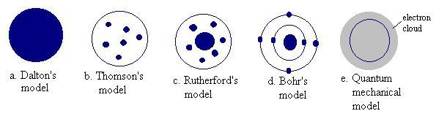
Quantum – electron clouds (orbitals) where there is a high probability of finding electrons

- Explain the difference between an orbit in Bohr’s model and an orbital in the quantum model.
Bohr – electrons orbiting nucleus in distinct energy levels (orbits)
Quantum – electrons in electron cloud /orbitals, a 3-D region where there is a high

probability of finding electrons

- Find the protons, neutrons, and electrons for each atom:

protons, electrons = atomic number (in an atom)

neutrons = mass – atomic number

Nitrogen (mass: 14) protons: 7 neutrons: 7 electrons: 7

Silver (mass: 108) protons: 47 neutrons: 61 electrons: 47

Rubidium (mass: 85) protons: 37 neutrons: 48 electrons: 37

- Draw an s, p, and d-orbital.

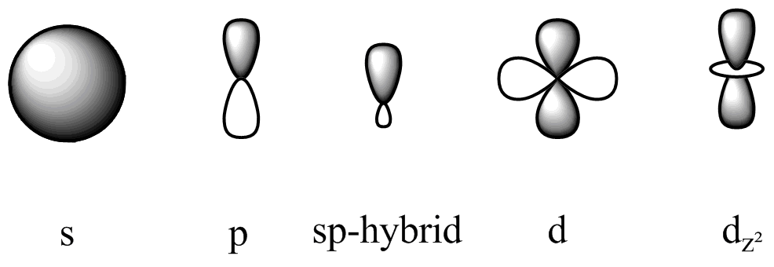

Electron Configurations
- Complete electron configurations:

Fluorine: 9 electrons
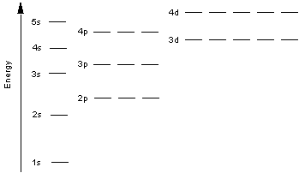

electron configuration notation: 1s²2s²2p⁵

Argon: 18 electrons

electron configuration notation: 1s²2s²2p⁶3s²3p⁶

Potassium: 19 electrons
electron configuration notation: 1s²2s²2p⁶3s²3p⁶4s¹

- Write the symbol for the elements with the following electron configurations:
- 1s²2s²2p⁶3s²3p⁶4s² Calcium Ca

- 1s²2s²2p³ Nitrogen N

- 1s²2s²2p⁶3s²3p⁵ Chlorine Cl

- 1s²2s22p63s23p³ Phosphorus P

Lab Application:
- What relationship is represented by the slope of a mass-volume graph? density
- A graph is plotted for several wheat pennies showing the mass along the y-axis and the number of pennies along the x-axis. Calculate the slope of this line.

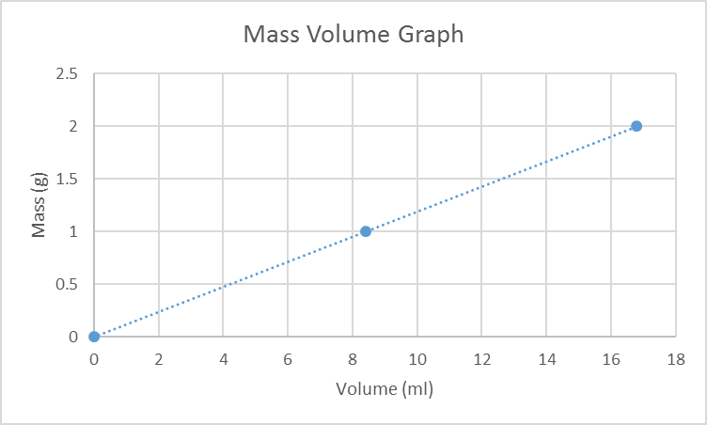

slope = rise = Y₂ – Y₁
run X₂ – X₁

slope = 2.0 – 1.0 = 0.4970414201183431952662721893491= .50
16.9 – 8.4

slope = .50 g/mL

