HONORS Chapter 1-3 Test Review Answers
Sig Figs:
- How many significant figures are in the following numbers:
a. 0.003 b. 42.0 c. 15.80
1 3 4
- Write the following answers to the correct number of significant figures:
a. 16.4 x 8 = 131.2 = 100 (rounded to 1 SF)

b. 894 / 34.2 = 26.1403509 = 26.1 (rounded to 3 SF)

c. 37.26 m - 2.7 m = 34.56 = 34.6 (reported to the least precise place value)

- What is the correct measurement with sig figs for the length of the black line?
5.50cm (any number 5.50-5.59 would be correct if reported to the hundredths place)

Lab Applications:
- Identify the chemical changes in the copper one tube lab. Review lab observations.
- What relationship is represented by the slope of a mass-volume graph? density
- A graph is plotted for several wheat pennies showing the mass along the y-axis and the number of pennies along the x-axis. Calculate the slope:

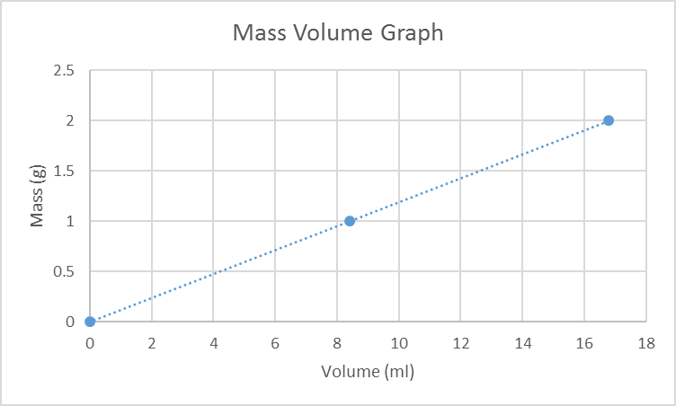
slope = rise = Y₂ – Y₁
run X₂ – X₁
slope = 2.0 – 1.0 = 0.4970414201183431952662721893491= .50
16.9 – 8.4
slope = .50 g/mL
Vocab:
- Define the following vocab terms: atom, compound, matter, mass, volume, density, accuracy, precision, isotope
Atom: the basic unit of matter
Compound: a substance composed of two of more elements
Matter: anything that has mass and volume
Mass: the quantity of matter in an object
Volume: the space an object occupies
Density: mass / volume
Accuracy: results are close the actual/accepted value
Precision: results are close to one another

History of the Atom:

- List the 5 main points of Dalton’s atomic theory and indicate which 2 points are no longer correct and explain why.
a. All matter is made of indivisible and indestructible atoms (nuclear fission/fusion)
b. All atoms of a given element are identical in their physical and chemical properties (isotopes –
different masses)
c. Atoms of different elements differ in their physical and chemical properties
d. Atoms of different elements combine in simple whole-number ratios to form compounds

e. Chemical reactions consist of the combination, separation, or rearrangement of atoms

- Be able to draw and compare/contrast the historical atomic models: Dalton, Thomson, Rutherford, Bohr, and the Quantum Mechanical models.
Dalton – earliest atomic model
Thomson – discovered electron, Plum Pudding model (electrons are in a positive “soup”)
Rutherford – discovered nucleus – electrons orbiting nucleus (but no distinction of energy levels)
Bohr – electrons orbiting nucleus in distinct energy levels (orbits)

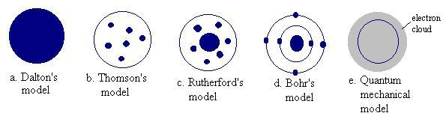
Quantum – electron clouds (orbitals) where there is a high probability of finding electrons

- Explain the difference between an orbit in Bohr’s model and an orbital in the quantum model.
Bohr – electrons obit the nucleus in distinct energy levels (orbits)
Quantum – electrons in electron cloud /orbitals, a 3-D region where there is a high

probability of finding electrons

- Identify the number of protons, neutrons, and electrons as indicated by isotopic notation:
Isotope | symbol | atomic # | mass # | # of  protons | # of electrons | # of  neutrons
Ruthenium - 103 | $\begin{aligned}{}_{\text{44}}^{\text{103}}{}\text{Ru} \\ \end{aligned}$ | 44 | 103 | 44 | 44 | 59
Strontium - 73 | $\begin{aligned}{}_{\text{38}}^{\text{73}}{}{\text{Sr}}^{2+} \\ \end{aligned}$ | 38 | 73 | 38 | 36 | 35
Hydrogen-2 | $\begin{aligned}{}_{1}^{2}{}H \\ \end{aligned}$ | 1 | 2 | 1 | 1 | 1
Mercury - 201 | $\begin{aligned}{}_{\text{80}}^{\text{201}}{}\text{Hg} \\ \end{aligned}$ | 80 | 201 | 80 | 80 | 121

- Draw an s, p, and d-orbital.

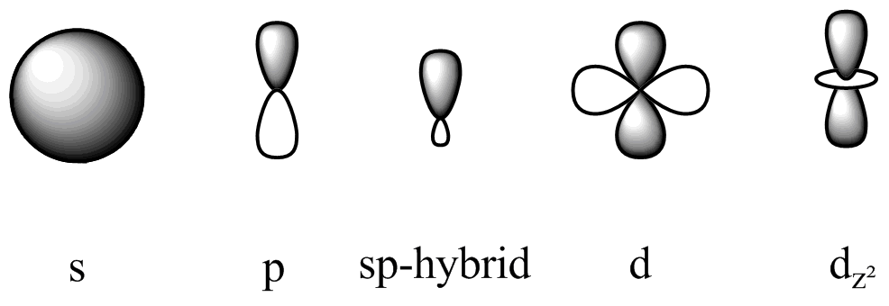

Electron Configurations
- Complete electron configurations for the following elements:

Germanium:
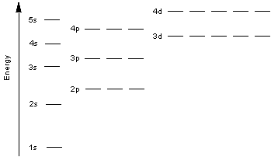
electron configuration notation: 1s²2s²2p⁶3s²3p⁶4s²3d¹⁰4p²

Noble Gas notation: [Ar]4s²3d¹⁰4p²

Zinc:
electron configuration notation: 1s²2s²2p⁶3s²3p⁶4s²3d¹⁰

Noble Gas notation: [Ar]4s²3d¹⁰

- Write the symbol for the elements with the following electron configurations:
- 1s²2s²2p⁶3s²3p⁶4s²3d¹⁰4p² Germanium Ge

- 1s²s²2p⁶3s²3p⁶4s²3d⁷ Cobalt Co

- [Xe]6s¹ Cesium Cs

