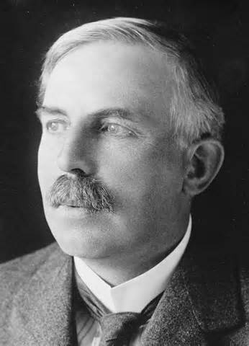

Using an iPad or computer create a visual (trifold brochure, Educreations presentation, Prezi, etc) to present your scientist’s contribution to atomic theory.

Information to include:

- Discuss your scientist’s contribution to atomic theory
- Include a picture of your scientist’s model of the atom
- Describe the experiment/ equipment (with picture if possible)
Project details:

  - You will present a brief description of your scientist and his/her contribution to atomic or nuclear theory, and answer any questions your classmates have about the contents of your trifold.
  - There will be a quiz on all the scientists afterward.
  - You will be working independently.
  - Please see the rubric for grading.

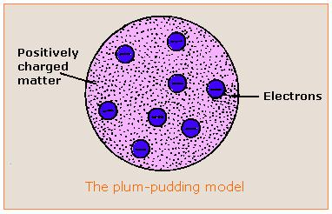

Designing the Trifold:

- The trifold should cover both sides of a sheet of paper. (Six columns). You may use this as a template.
- Include at least 1 picture, and make sure any pictures look okay in black and white for printing.

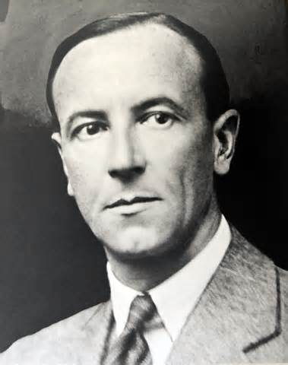

Atomic Scientists Project

Research the contributions of one of the following scientists to our knowledge of the atom or nucleus:

- John Dalton
- JJ Thomson
- Ernest Rutherford
- Henry Moseley
- Robert A. Millikan
- James Chadwick
- Niels Bohr
- Henry Moseley
- Werner Heisenberg
- Erwin Schrödinger
- Louis de Broglie
- modern: quantum mechanics

Sign up for the scientist you wish to research.

Give a brief overview of your scientist on this page. This is the first page the reader will see after opening the brochure.

Works Cited
  - The information you need can come from your textbook and internet research.
  - You must cite at least 3 sources.
  - Do NOT use Wikipedia as a source.

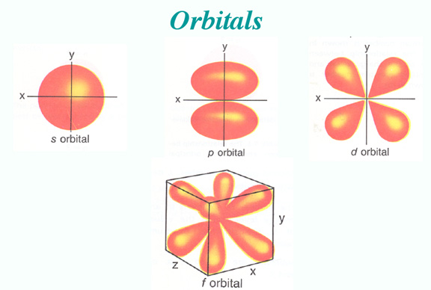

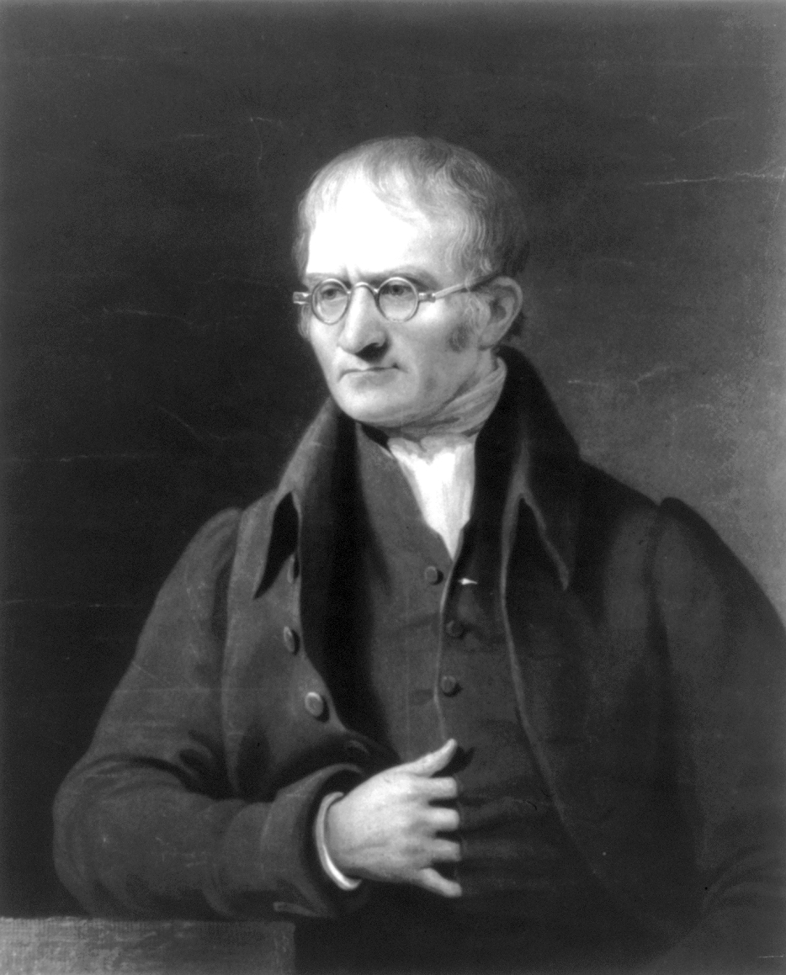

- This page can be for the title (your scientist’s name) and your name.

by
Student Name

