Quantum Mechanics and Split Peas

Introduction
We have seen that Bohr was close explaining the true nature of the electron. His model worked well for the hydrogen atom; however, Bohr’s theories were too simplistic for multi-electron systems. It was evident that a new type of thinking would be needed to where an electron would most likely be in an atom. Quantum Mechanics uses the concept of "probability" to predict where an electron would most likely be in the atom. This area of the atom was called the electron cloud. Erwin Schrodinger's study of quantum mechanics further pinpointed the electron's location to regions he called the shell, subshell, and orbital. The following exercise will allow us to use the concept of probability and relate it to Schrodinger's quantum mechanics.
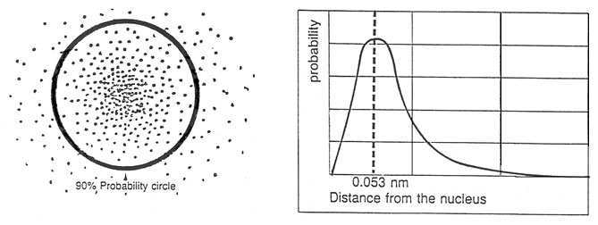

Purpose
In this activity, we will attempt to concretize the ideas of quantum mechanics, orbitals, and probability models.

Materials
40 mL of split peas
Funnel
Target

Procedure
- Gather 40mL of peas and split in half (20 mL in 2 graduated cylinders).
- Place a finger over the end of the funnel and add 20 ml of the peas into the funnel.
- Position the target so that the funnel is directly over the center of the target.
- Release the peas so that they fall on the target.
- Count how many peas are in each area of the target.
- Record data on the data table.
- After completing the counting, repeat steps 1-5 with all 40 ml of peas.
- Clean up by collecting any stray peas and returning peas to the designated beaker.

Rules for counting:
- If a pea is completely within an area, it belongs to that area.
- If the pea is on a line, it belongs to the area nearest the center.
6
5
4
3
2
1
The areas are numbered as this picture.

Data Table
Run 1
Area # | # of peas | % of total
1
2
3
4
5
6
Total

Questions (Please fully explain each answer.)

- Plot the number of peas (y-axis) vs. maximum radial distance for each target area (x-axis).
(in class excel spreadsheet)

- Which area did the most peas land in?

- Identify the radius of maximum probability from the graph (peak of the curve)

- Where would you predict 90% of the peas would fall?

- Does your 90% prediction mean that every pea will fall where you think?

- How does the shape of your graph compare with Schrodinger’s probability graph for the location of the single electron in the hydrogen atom? Explain how these results mimic the orbitals described in the quantum mechanical model of the atom.
Radial probability curve for the s-electron.
- Which point (A-E) is the greatest probability of finding the electron?

- Where is there zero probability of finding the electron?

- As the distance from the nucleus increases, what happens to the probability of finding an electron?

