Name: _______________________________

ATOMIC PARTICLE PROFILE

 | location | electrical charge | # of particles
proton
neutron
electron

isotope: ______________________________________________________________________

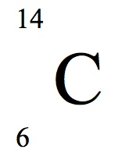

${}_{\text{38}}^{\text{73}}{}\text{Sr}$

# p: _____ # p: _____

# n: _____ # n: _____

# e⁻:_____ # e⁻:_____

element | Isotopic  Notation  Co | atomic # | # of  protons | # of electrons | mass # | # of neutrons
60
27
207
Pb
82
1
H
1
F
20
9
238
U
92
Ti
48
22

