Name: Academic Electron Configuration Practice
Draw electron configurations for the following atoms then write in configuration notation

- Chlorine # of electrons: _____

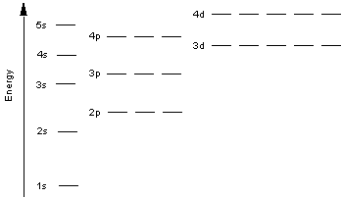

electron configuration notation: __________________________________________________

- Magnesium # of electrons: _____

electron configuration notation: __________________________________________________

- Carbon # of electrons: _____

electron configuration notation: __________________________________________________

- Aluminum # of electrons: _____

electron configuration notation: __________________________________________________

- Oxygen # of electrons: _____

electron configuration notation: __________________________________________________

- Phosphorus # of electrons: _____

electron configuration notation: __________________________________________________

Write the symbol for the elements with the following electron configurations:

- 1s²2s²2p⁶

- 1s²2s¹

- 1s²2s²2p⁶3s²3p⁵

- 1s²s²2p⁶3s²3p¹

What is wrong with the following electron configurations?
a. 1s22s22p23s2

b. 1s22s8

Write electron configuration for the following atoms using electron configuration notation:
- Sulfur

- Beryllium

- Neon

- Chlorine

- Silicon

