Name: __________________________

HONORS Chapter 1-3 Test Review

Sig Figs:
- How many significant figures are in the following numbers:
a. 0.003 b. 42.0 c. 15.80

- Write the following answers to the correct number of significant figures:
a. 16.4 x 8 =

b. 894 / 34.2 =

c. 37.26 m - 2.7 m =

- What is the correct measurement with sig figs for the length of the black line?

Lab Applications:
- Identify the chemical changes in the copper one tube lab.
- What relationship is represented by the slope of a mass-volume graph? ____________
- A graph is plotted for several wheat pennies showing the mass along the y-axis and the number of pennies along the x-axis. Calculate the slope:

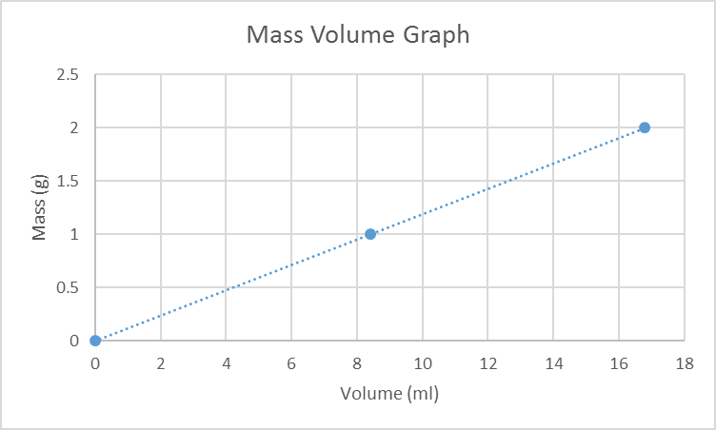slope = __________ g/mL

Vocab:
- Define the following vocab terms: atom, compound, matter, mass, volume, density, accuracy, precision, isotope

History of the Atom:

- List the 5 main points of Dalton’s atomic theory and indicate which 2 points are no longer correct and explain why.

- Be able to draw and compare/contrast the historical atomic models: Dalton, Thomson, Rutherford, Bohr, and the Quantum Mechanical models.

- Explain the difference between an orbit in Bohr’s model and an orbital in the quantum model.

- Identify the number of protons, neutrons, and electrons as indicated by isotopic notation:
Isotope | symbol | atomic # | mass # | # of  protons | # of electrons | # of  neutrons
 | $\begin{aligned}{}_{\text{44}}^{\text{103}}{}\text{Ru} \\ \end{aligned}$
 | $${}_{\text{38}}^{\text{73}}{}\text{Sr}$$
Hydrogen-2
 |  |  | 201 | 80

- Draw an s, p, and d-orbital.
Electron Configurations
- Complete electron configurations for the following elements:

Germanium:
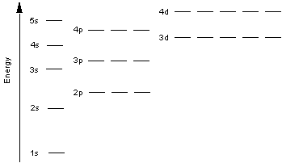
electron configuration notation: __________________________________________________

Noble Gas notation: __________________________________________________

Zinc:
electron configuration notation: __________________________________________________

Noble Gas notation: __________________________________________________

- Write the symbol for the elements with the following electron configurations:
- 1s²2s²2p⁶3s²3p⁶4s²3d¹⁰4p²

- 1s²s²2p⁶3s²3p⁶4s²3d⁷

- [Xe]6s¹

