Name: __________________________

Chapter 1-3 Test Review

Sig Figs:
- How many significant figures are in the following numbers:
a. 0.003 b. 42.0 c. 15.80

- Write the following answers to the correct number of significant figures:
a. 16.4 x 8 =

b. 894 / 34.2 =

c. 37.26 m - 2.7 m =

- What is the correct measurement with sig figs for the length of the black line?

Vocab:
- Define the following vocab terms: atom, compound, matter, mass, volume, density, accuracy, precision, isotope

History of the Atom:

- Be able to draw and compare/contrast the historical atomic models: Dalton, Thomson, Rutherford, Bohr, and the Quantum Mechanical models.

- Explain the difference between an orbit in Bohr’s model and an orbital in the quantum model.

- Find the protons, neutrons, and electrons for each atom:

Nitrogen (mass: 14) protons: ___ neutrons: ___ electrons: ___

Silver (mass: ____) protons: ___ neutrons: 60 electrons: ___

______________ (mass: 85) protons: 37 neutrons: ___ electrons: ___

- Draw an s, p, and d-orbital.

Electron Configurations
- Complete electron configurations:

Fluorine:
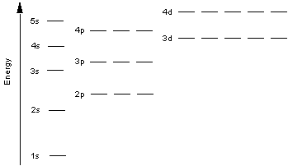
electron configuration notation: __________________________________________________

Argon:
electron configuration notation: __________________________________________________

Potassium:
electron configuration notation: __________________________________________________

- Write the symbol for the elements with the following electron configurations:
- 1s²2s²2p⁶3s²3p⁶4s²

- 1s²2s²2p³

- 1s²2s²2p⁶3s²3p⁵

- 1s²2s22p63s23p3

Lab Application:
- What relationship is represented by the slope of a mass-volume graph? ____________
- A graph is plotted for several wheat pennies showing the mass along the y-axis and the number of pennies along the x-axis. Calculate the slope of this line.

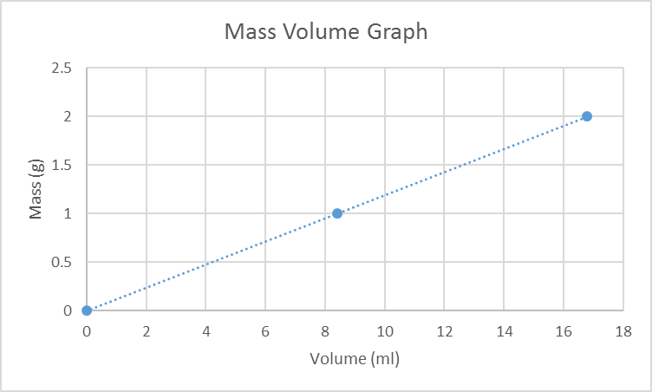

slope = __________ g/mL

