Characteristics of Life
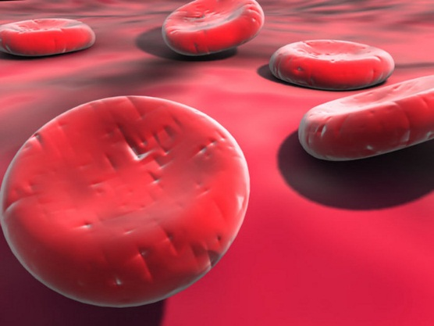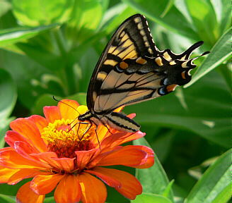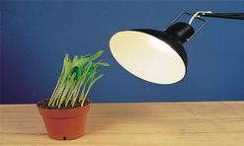
 | Compare/Contrast |  | Compare/Contrast
Reproduction |  | Adaptations to Environment
Cells and Organization |  | Homeostasis/ Response to Stimuli
Energy Use |  | Growth & Development

