Academic Chemistry Final 2015

Study Guide ANSWERS

Academic Chemistry Final:

36 Multiple Choice Questions

17 Short Answer/Calculations

Resources for the final exam
- You will be given a periodic table/ion chart and a formula sheet of equations.
- You may use a calculator (NO cell phones).

Formula Sheet:

Gas Laws:

P₁V₁ = P₂V₂
T₁ T₂

PV = nRT

P = Pressure (atm)
V = Volume (Liters)
n = amount (moles)
R = .0821 _{L • atm} = Universal Gas Constant
^{mol • K}
T = temperature (Kelvin)

1 L = 1000 mL

1 atm = 760 mmHg

1 atm = 101.3 kPa

STP = 273K and 1 atm

22.4L in 1 mole at STP

Mixtures:

Molarity = mol
L
M = Molarity or molar

Acids and Bases:

pH = -log [H⁺]

pH = power of Hydrogen concentration

[H⁺] = concentration of Hydrogen ions

Chapter 10: Stoichiometry

Vocabulary

- law of conservation of matter
- molar ratios

Be able to….

- Determine molar ratios

Practice Problems:
Use the following balanced equation to answer questions using mole ratios:

2Al₂(CO₃)₃ + 3H₂SO₄ 2Al₂(SO₄)₃ + 3 H₂O + 3CO₂

  - 2:3 What is the molar ratio for Al₂(CO₃)₃ and H₂O?

  - 3 mol How many moles of CO₂ are produced when 3 moles of H₂SO₄ react?

  - .37 g H₂O How many grams of H₂O are produced when 2.0g of H₂SO₄ reacts?

H₂B₄O₇(s) + H₂O(l) → 4HBO₂(aq) + 11.3 kJ

  - 1:4 What is the ratio of H₂B₄O₇ to HBO₂ ?

  - 2.5 mol How many moles of tetraboric acid (H₂B₄O₇) are needed to make 10 moles of metaboric acid (HBO₂)?

  - 45 g How many grams of HBO2 are produced by 70 g of H₂B₄O₇?

Chapter 11: Heat & Energy

Vocabulary

- heat

  - temperature

Be able to….

- Identify exothermic vs endothermic reactions.
- Compare sources of energy for transportation, electricity, and heating.

Practice Problems:
Label each reaction example as exothermic or endothermic:
- 2H2(g) + O2(g) → 2H2O(g) ΔH°= -243 kJ exothermic (ΔH is negative)
- H2B4O7(s) → B2O3(s) + H2O(l) feels warm exothermic (exo = warm)
- H2B4O7(s) + H2O(l) → 4HBO2(aq) + 11.3 kJ exothermic (energy is a product)

Sources of energy:
- What is the most common source of energy for transportation? gasoline (derived from OIL)
What are three alternatives? diesel, ethanol, biodiesel, fuel cell car, etc.
Which do you think is best? Explain two reasons: opinion question, support with evidence

- What is the most common source of energy for electricity? coal
What are three alternatives? natural gas, nuclear, hydropower, solar, etc.
Which do you think is best? Explain two reasons: opinion question, support with evidence

- What is the most common source of energy for home heating? natural gas, oil
What are three alternatives? geothermal, solar, etc.
Which do you think is best? Explain two reasons: opinion question, support with evidence

Chapter 12: Gases

Vocab:

- Kinetic Molecular Theory
- Atmospheric pressure
- Temperature
- Kinetic Energy
- Pressure
- STP

Be able to….
- Compare/ contrast the characteristics of solids/ liquids/ gases
- Describe the Kinetic-Molecular theory and explain how it explains gas behavior.
    - Define Temperature in terms of particles:
      - temperature is kinetic energy (motion of particles)
- Explain what gas pressure means and describe how it is measured.
      - Pressure is collisions of the particles/ molecules with the walls of the container (force/area)
      - Measured by a barometer; units = atmospheres, mmHg, kPa, torr
- Solve problems using the gas laws.

Practice Problems:
Compare the characteristics of solids/ liquids/ gases:
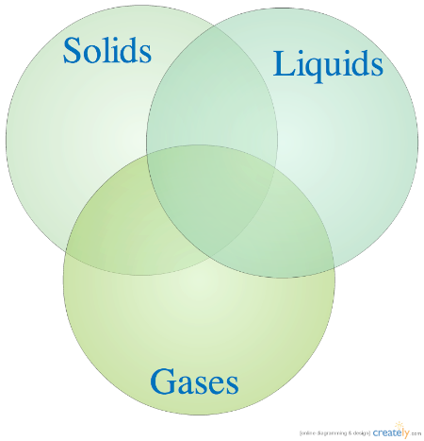
Solids definite shape, definite volume; particles vibrate in position
Liquids indefinite shape, definite volume
Gases indefinite shape, indefinite volume; particles are far apart (low density, compressible);
particles move in straight lines and collide with walls of the container

- 91 K A 3.00 liter (V₁) sample of neon gas at 0°C (T₁ = 273 K) and 1.25 atm (P₁) is compressed into a 1.00 liter (V₂) container. If the pressure remains constant, what temperature will the container be?
T₂ = P₂V₂T₁ T₂ = V₂T₁ = 1.00L x 273 K = 91 K
P₁V₁ V₁ 3.00L

- 96.22atm What is the pressure (P = ?) exerted by 2 moles of oxygen confined to a volume of 500 mL (V = .500L) at 20 °C (T = 293 K)?
P = nRT = 2.0mol x .0821 x 293 K = 96.22atm (this Pressure seems really high?)
V .500L

- 1.3 mol How many moles of gas are in a 52 L (V) sample collected at 220 K (T) and .444atm?
n = PV = .444atm x 52L = 1.3 mol
TR 220K x .0821

- 4.9 L Find the new volume (V₂ = ?) when a 2.1 L (V₁) sample of a gas collected at 245 Kelvin (T₁) and 2.1atm (P₁) is changed to standard conditions (STP: T₂ = 273 K, P₂ = 1 atm).
V₂ = P₁V₁T₂ = 2.1 atm x 2.1 L x 273 K = 4.9 L
T₁P₂ 245 K x 1 atm

- 23 mL Find the new volume (V₂= ?) of a gas that changes 65 ml (V₁) at 150 mmHg (P₁) to 425 mmHg (P₂).
V₂ = P₁V₁T₂ = V₂ = P₁V₁ = 150 mmHg x 65 mL = 23 mL
T₁P₂ P₂ 425 mmHg

- Explain the relationship between each of the variables for the following gas laws:

Boyle’s Law:
as P increases, V must increase if T and n are constant

Charles’ Law:
as T increases, P increases (greater T = more movement = more collisions)

Avogadro’s Law:
as n (moles) increases, V increases (think about blowing up a balloon)

Chapter 13: Solutions

Vocab

- solute substance that dissolves (ex iced tea mix)
- solvent substance that does the dissolving (ex water)
- saturated a solution that can hold no more solute
- unsaturated a solution that can hold more solute
- supersaturated a solution that has extra solute than when saturated
- polar/non-polar “like dissolves like” polar dissolves in polar; oil & water
- soluble a solid solute does dissolve in a solvent
- insoluble a solid solute does NOT readily dissolve in a solvent
- solubility curve graph illustrating solubility versus temperature of various solutes in 100g of a solvent
- miscible two liquids dissolve in one another (“like dissolves like”)
- immisicle two liquids do not mix in one another (polar/nonpolar)
- solution a homogenous mixture (kool-aid, salt water)
- colloid particles are dispersed (cloudy milk, mayo)
- suspension particles settle to the bottom (muddy water)
- Molarity a unit of concentration in moles / liter

Be able to…
  - Classify mixtures as solutions, colloids, or suspensions
  - Explain colligative properties and relate to practice applications
    - salting roads, ice cream
    - adding a SOLUTE to a solvent changes the properties of a solvent (ex: lowering freezing point or increasing melting point)
    - only IONIC compounds (compounds that will dissolve in water) will change the properties of water
  - Interpret a solubility curve
  - Identify substances as saturated, unsaturated, or supersaturated
  - Calculate molarity

Practice Problems:
Interpret solubility curves:
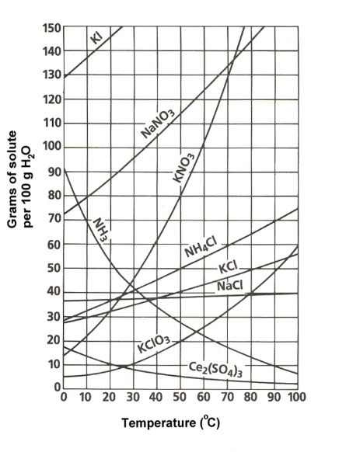
- What substance is most soluble at 20ºC?
KClO₃
- What substance is least soluble at 90 ºC?
Ce₂(SO₄)₃
- What is the solubility of KNO₃ at 50 ºC?
80 g
- How many grams of NaNO₃ can dissolve in 100 grams of water at 60° C?
122 - 123 g
- If 70g of KCl is dissolved at 70 ºC, is the solution saturated, unsaturated, or supersatured?
supersaturated
- .33M Calculate the molarity when 2 mol of CuSO₄ dissolves in 6L of water.

2 mol = .33M
6 L

- .80M Find the molarity when 2.0 mol NaCl is dissolved in 2500mL of water.

2.0 = .80M
2.500 L

- .005mol How many moles of HCl is needed to prepare 1.5 L of a 0.010 M solution.

1.5L x .010 mol = .005mol
1L

Chapter 15: Acids and Bases:

Vocabulary
- Arrhenius Acid
- Arrhenius Base
- dissociation

Be able to…
- Identify substances in chemical equations as acids or bases
  - Example Acid formulas :

  - Example Base formulas:

- Identify the common physical and chemical properties of acids and bases
- Calculate pH of solutions

Practice Problems:
Label the properties of acids and bases:
 | Acids | Bases
Dissociates into ____ ions | H⁺ | OH⁻
pH range? | 0-7 | 7-14
Taste? | Sour | Bitter
Feels? |  | Slipper
Conducts Electricity? | Yes | Yes
Turns litmus paper red/blue | Pink | Blue
Turns Phenolphthalein clear/pink | Clear | Pink

- 3 Find the pH of a 1.0 x 10⁻³ M solution of HCl
pH = -log [1.0 x 10⁻³] = 3

- 8 Find the pH of a NaOH solution where H⁺ = [1.0 x 10⁻⁸]
pH = -log [1.0 x 10⁻⁸] = 8

Chapter 16: Reaction Rates

Vocabulary
- Collision Theory reactions are caused by collisions
- Catalyst increases a reaction by lowering activation energy

Be able to…
- Describe the two conditions for a successful chemical reaction
  - enough energy to overcome the activation energy and correct molecular orientation
- Understand chemical reactions in terms of collision theory
- Be able to list and describe the 5 factors that affect reaction rates

Practice Problems:
- What are the conditions for a chemical reaction to occur?
1) particles need enough energy to overcome the activation energy and
2) correct molecular orientation

- Explain how the following factors change reaction rates:

- surface area of a solid reactant
increase surface area (powder) because a greater surface area means there are more possible sites for collisions = faster reaction

- concentration of a reactant
increase concentration so that there are more reactant particles which means more collisions = faster reaction

- temperature
increase temperature because temperature is a measure of the average kinetic energy, so particles move faster and collide more often = faster reaction

- nature of the reactants
the reactants must react with one another for a reaction to occur

- presence of a catalyst
catalysts speed up reactions by lowering the activation energy

