Trends in Atomic Size (pages 134-137 in textbook on website)
- What is an atomic radius?

- Draw the general trend of atomic radius down a group and across a period.

- For each pair of elements, circle the larger atom:

  - He and Ar
  - Al or B
  - Na or Al
  - S or O
  - O or F
  - Br or Cl

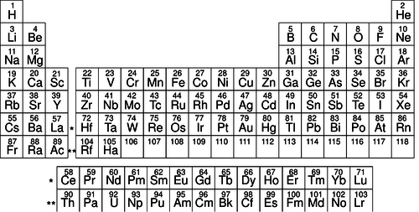
- Rank in order of INCREASING atomic radius
- Ca, K, Br _________________________
- Mg, Na, Cl _________________________
- Al, B, or In _________________________

- Rank in order of DECREASING atomic radius
- Cl, Br, At _________________________
- Ne, Li, C _________________________
- Ca, Ra, Sr _________________________

Trends in Ionization Energy (pages 137-139 in textbook on website)
- What is ionization energy?

- Draw the general trend of ionization energy with down a group and across a period.

- For each pair of elements, circle the element that has the greater first ionization energy:

  - Li or K
  - Li or Be
  - Ca or Ba
  - Na or K
  - P or Ar
  - Cl or Si

- Rank in order of INCREASING ionization energy
- O, S, Ge _________________________
- C, Pb, F _________________________
- Be, Ba, B _________________________

- Rank in order of DECREASING ionization energy
- Al, P, Ag _________________________
- Cl, Cu, Au _________________________
- Te, I, Xe _________________________

Trends in Electronegativity (pages 198 in textbook on website)
- What is electronegativity?

- Draw the general trend of electronegativity with down a group and across a period.

- What is the most electronegative element? _____
- For each pair of elements, circle that atom that has the greater electronegativity:

- Ca or Ga
- Br or As
- Li or O
- Ba or Sr
- Cl or S
- O or S

- Rank in order of INCREASING electronegativity
- V, Y, O _________________________
- Na, K, Ne _________________________
- Fr, Ca, Co _________________________

- Rank in order of DECREASING electronegativity
- As, Se, Sn _________________________
- Xe, Ru, Hf _________________________
- Sb, N, He _________________________

