The Periodic Table
Use colored pencils to color in the periodic table.
Follow the directions carefully…you only get one table to color.

- The following elements are metalloids: B, Si, Ge, As, Sb, Te, and Po. Color them and be sure to color the key. Read pages 118-119 to describe the properties of metalloids in your notes.
- The elements in periods (rows) 2 through 7 that are to the left of the “staircase” are metals. Chose a color to outline (don’t color!) the metals and label the key. Read pages 118-119 and 135-131 to describe the properties of metals in your notes.
- The elements in periods 1 through 6 that are to the right of the “staircase” are nonmetals. Chose a color to outline (don’t color!) the nonmetals. Don’t forget hydrogen…it’s a little out of place. Read pages 118-119 to describe the properties of nonmetals in your notes.
- The alkali metals are in group (column) 1. They have only one electron in their outer shell. They are VERY reactive and have a low melting point. Color the alkali metals. Read page 119 to describe the properties of alkali metals in your notes.
- Alkaline earth metals are located in group 2. They have 2 electrons in their outer energy level. Color the alkaline earth metals. Read page 120 to describe the properties of alkaline earth metals in your notes.
- The noble gases are found in group 18. Their outer energy level is filled, and they are very non reactive, colorless gases. Color the noble gases. Read page 122 to describe the properties of noble gases in your notes.
- Halogens have seven electrons in their outer shell. They are located in group 17 on the periodic table. Halogens are the most reactive nonmetals and react with metals to form salts. Shade the halogens green. Read pages 121-122 to describe the properties of halogens in your notes.
- The transition elements are found in groups 3 through 12 and periods 4 through 7. These elements have either one or two electrons in the outer energy level. They are often used to form alloys because they are hard and have high melting points. Color the transition metals.
- Below the main part of the table are two rows of elements. These elements are part of the transition metal section. The top row is called the Lanthanide Series and the bottom section is called the Actinide Series. Label each series and color these rows using the same color you use for the transition metals. Read pages 120-121 to describe the properties of the lanthanide and actinide series.

Alkali Metals Group # __  Pg. 119  Properties of this Group: | Lanthanides & Period # __  Actinides Period # __  Pg. 120-121  Properties of these Periods:
Alkaline Earth Metals Group # __  Pg. 120  Properties of this Group: | Metals location: ____________  Pg. 118-119, 125-131  Properties of Metals:
Halogens Group # __  Pg. 121-122  Properties of this Group: | Metalloids location: ____________  Pg. 118-119  Properties of Metalloids:
Noble Gases Group # __  Pg. 122  Properties of this Group: | Non-Metals location: ____________  Pg. 118-119  Properties of Non-Metals:

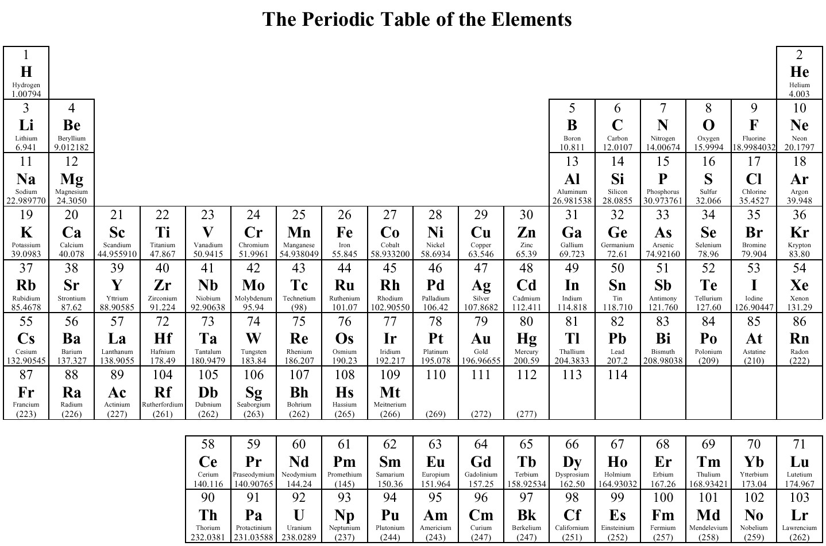
G 1
G 2
G 3
G 4
G 5
G 6
G 7
G 8
G 9
G 10
G 11
G 12
G 13
G 14
G 15
G 16
G 17
G 18
P 1
P 2
P 3
P 4
P 5
P 6
P 7

Metal Alkali Metals

Nonmetal Alkaline Earth Metals
Metalloids Halogens
Transition Metals Nobel Gases

Periodic Table Basics Name ____________________________

- What are the properties of metals? List 5 metals.
_________________________________________________________________________

- What are the properties of nonmetals? List 5 nonmetals.
_________________________________________________________________________

- What is a metalloid? List the metalloids.
_________________________________________________________________________

- What do you notice about the number of valence electrons as you move from left to right across a row or period in the periodic table? (Ex: Na Mg Al Si P S Cl Ar)
_________________________________________________________________________

- What do you notice about the number of energy levels or shells as you move down a group or column in the periodic table? (Ex: H Li Na)
_________________________________________________________________________

- Elements are organized into families according to their physical and chemical properties. Identify the number of valence electrons for each group of elements.
Alkali Metals - ___ valence electron
Alkaline Earth Metals - ___ valence electrons
Boron Family - ___ valence electrons
Carbon Family - ___ valence electrons
Nitrogen Family - ___ valence electrons
Oxygen Family - ___ valence electrons
Halogens - ___ valence electrons
Noble Gases - ___ valence electrons

- How would you classify hydrogen? Why?
_________________________________________________________________________

- Predict the valence electrons for each element based on its location on the Periodic Table:

Barium = ____ Lead = ____ Xenon = ____ Francium = ____

- Describe the properties of the following groups on the Periodic Table:
Alkali Metals -
Alkaline Earth Metals -
Halogens -
Noble Gases -
Vocabulary: The Periodic Table
Choose words from the list to fill in the blanks in the paragraphs below.
Vocabulary List

actinide series
alkali metals
alkaline earth metal
atomic mass
atomic number
energy level
family
group
halogen
lanthanide series
metal
metalloid
noble gas
nonmetal
period
periodic law
periodic table
transition element

Dmitri Mendeleev developed a chart-like arrangement of the elements called the ____________________. He stated that if the elements were listed in order of increasing ____________________, their properties repeated in a regular matter. He called this the ____________________ of the elements. The arrangement used today differs from that of Mendeleev in that the elements are arranged in order of ____________________. ____________________ developed the table in this way. Each horizontal row of elements is called a(n) ____________________ and represents the __________ __________ Each vertical column is called a(n) ____________________, or ____________________ because of the resemblance between elements in the same column.

In rows 4 through 7, there is a wide central section containing elements, each of which is called a(n) ____________________. Rows 6 and 7 also contain two other sets of elements that are listed below the main chart. These are called the ____________________(row 6) and the ____________________(row 7). Each of these elements, as well as any element to the left of the “staircase”, is classified as a(n) ____________________. Each of the elements at the right side of the chart is classified as a(n) ____________________. Each of the elements between these two main types, having a mixture of properties, is called a(n) ____________________.

Each of the elements in the column labeled 1A is called a(n) ____________________. Each of the elements in the column labeled 2A is called a(n) ____________________. Each of the elements in column in column 7A is called a(n) ____________________. Each of the elements in column 8A is called a(n) ____________________.

