Concept Mapping: Cellular Structure, Function, and Organization

Learning Targets:
- I can compare and contrast the cell structure of prokaryotic and eukaryotic cells.
- I can compare and contrast the cell structure plant and animal cells.
- I can relate the structure and function of individual cells to a hierarchical organization of organisms.

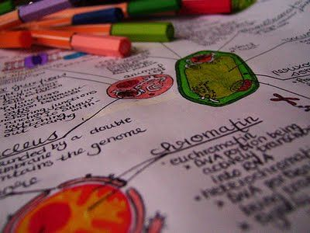
- Create a concept map using the Popplet or Educreation apps on an iPad, bubbl.us on a computer, or with markers on chart paper.

- With your group, define and discuss how the following vocabulary are related to one another:

prokaryote
eukaryote
animal cell
plant cell
organelles
cell membrane
nucleus
chloroplasts
cell wall
ribosomes
nucleoid region
fungi
animal
plant
bacteria
protist
fungi
unicellular
multicellular
atoms
molecules
organelles
cells
tissues
organs
organ systems
living organism

- Design a concept map that shows a relationship between the learning targets and depicts how organisms are organized at the cellular level. You can design the concept map any way you'd like that makes sense to you and your group.
  - If working on the ipad or computer, you may want to define each vocabulary in a separate “bubble” and then move the bubbles around as your group discusses the relationships and organization in creating the concept map.
  - If working on chart paper, you may want to define each word on separate paper so that you are then able to move the papers around as you discuss the different relationships and overall organization.

- As you create relationships, you need to clearly describe the connection and your reasoning. You can add new bubbles/ webs/ text to show these thoughts/ connections.

- You also need to include pictures (either drawn or printed) to better help visualize the similarities and differences that you generate.

- If you create your concept map on the iPad or computer, please send me a picture or link in an email to sverissimo@wlps.org so that I can view your project.

Cell Structure Concept Map
Using the terms and phrases provided below, complete the concept map showing the characteristics of cells.

animal cells
capsule
cell membrane
cell wall
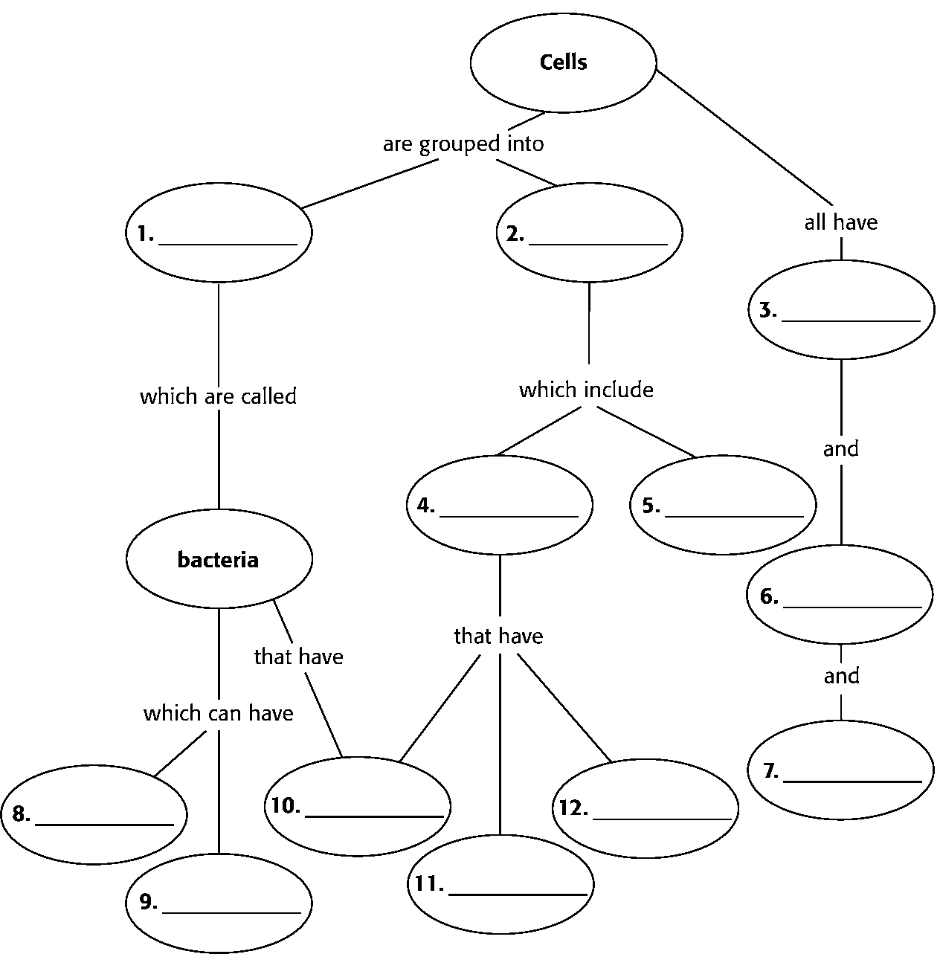
central vacuole
chloroplasts
cytoplasm
eukaryotes
pili
plant cells
prokaryotes
ribosome

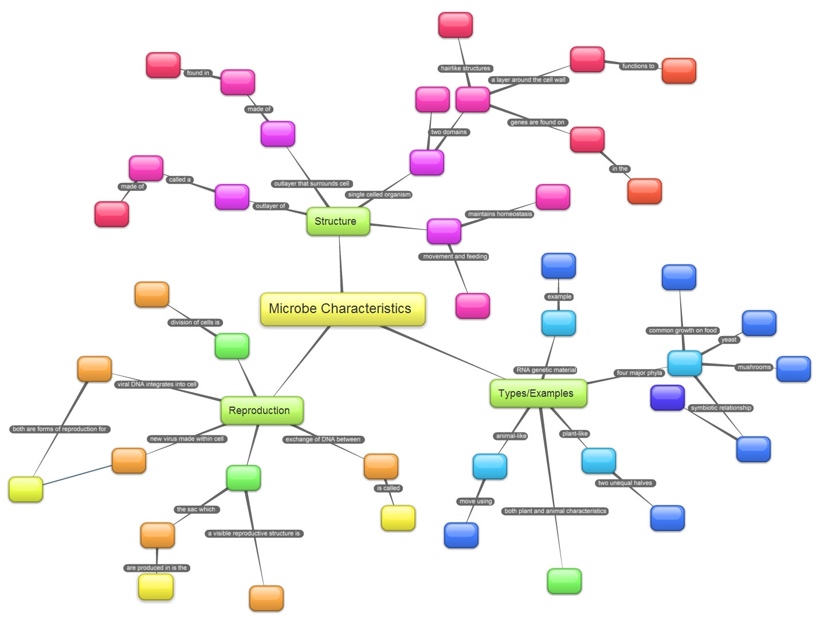
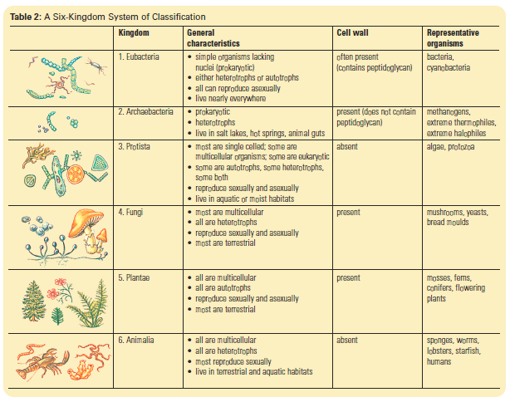

Concept Map: Cellular Structure, Function, and Organization Rubric
 | Exceeds Standard  4 | Meets Standard  3 | Progress to Standard  2 | Limited Progress  1
Vocabulary | All essential vocabulary (27 words) is accurately defined in relation to the cellular structure of organisms. | Most vocabulary (>20 words) is accurately defined in relation to the structure of cells. | Some vocabulary (>10 words) is defined. | A limited amount of essential vocabullary is defined (<10 words).
Concept Map Relationships | Vocabulary is arranged in a thoughtful manner that makes logical sense of the differences and relatinoships between the different types of cells and these connections are clearly written on the concept map. | Vocabulary is arranged in a manner that makes sense of the differences and relatinoships between the different types of cells. | Vocabulary is arranged in a manner that makes sense of the differences between the different types of cells. | There is limited progress in representing how the vocabulary relates to the different types of cells.
Prokaryote/ Eukaryotes  I can compare and contrast the cell structure of prokaryotic and eukaryotic cells. | The similarities and differences between prokaryates and eukaryotes are accurately represented on the conecpt map. | The differences between prokaryates and eukaryotes are accurately represented on the conecpt map. | Some differences between prokaryates and eukaryotes are represented on the conecpt map. | There is limited progress in describing the differences between prokaryotes and eukaryotes.
Plant/ Animal Cells  I can compare and contrast the cell structure plant and animal cells. | The similarities and differences between plant and animal cells are accurately represented on the conecpt map. | The differences between plant and animal cells are accurately represented on the conecpt map. | Some differences between plant and animal cells are represented on the conecpt map. | There is limited progress in describing the differences between plant and animal cells.
Organization of Organisms  I can relate the structure and function of individual cells to a hierarchical organization of organisms. | The kingdoms of organisms (bacteria, plant, animal, fungi, and protist) are accurately arranged in a way that makes sense of a hierarchical organization of different types of cells: prokaryotic/ eukaryotic, animal/ plant cells, multicellular/ unicellular, similiarities/ difference in cellular organelles. | The kingdoms of organisms (bacteria, plant, animal, fungi, and protist) are arranged into organized groups of different cell types: prokaryotic/ eukaryotic, animal/ plant cells, multicellular/ unicellular, similiarities/ difference in cellular organelles. | The kingdoms of organisms (bacteria, plant, animal, fungi, and protist) are generally arranged into groups of different cell types: prokaryotic/ eukaryotic and animal/ plant cells. | There is limited progress in arranging the kingdoms of organisms to a hierarchical organization symstem of cell types.
Visual Presentation | The concept map is extremely well organized, contains both text and quality pictures (5), and clearly shows the differences and relationships amongst the different types of cells. | The concept map is organized, contains both text and some pictures (3), and clearly shows the differences and relationships amongst the different types of cells. | The concept map is fairly organized, contains text and a picture (1), and clearly shows the differences amongst the different types of cells. | The concept map includes text only and the lack of rganization of ideas distracts viewers from interpreting the differences and relationships between types cells.

