The Mendeleev Lab of 1869
Adapted from Holt Chemistry: Visualizing Matter, 2000

Problem:

Use your knowledge of the periodic table to determine the identity of each of the nine unknown elements in this activity.

❑ The unknown elements are from the following groups in the periodic table. Each group listed below contains at least one unknown.

1 2 11 13 14 17 18

❑ None of the known elements serve as one of the nine unknown elements.
❑ No radioactive elements are used during this experiment. The relevant radioactive elements include Fr, Ra, At, and Rn.
❑ You may not use your textbook or other reference materials. You have been provided with enough information to determine each of the unknown elements.

Procedure:

1. Arrange the cards of the known elements in a representation of the periodic table.
2. Inspect the properties of the known elements.
3. Analyze the properties of the unknowns to see where their properties would best fit the trends of the elements of each group.
4. In your data table, assign the proper element name to each of the unknowns and justify your reasoning.

Identifying the Unknowns:
Unknown | Justification
Unknown #1
Unknown #2
Unknown #3
Unknown #4
Unknown #5
Unknown #6
Unknown #7
Unknown #8
Unknown #9

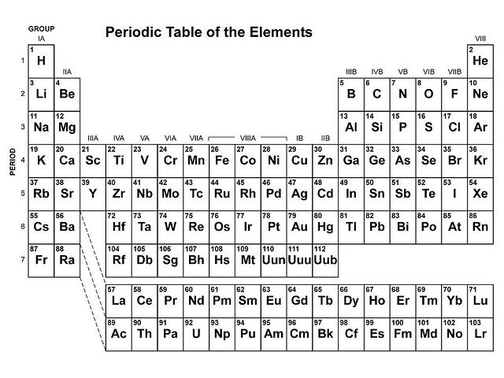

Li  Physical State solid  Density 0.534 g/cm³  Hardness soft, claylike  Conductivity good  Solubility (H₂O) reacts with water  Melting Point 180ºC  Color silver | Cl₂  Physical State gas  Density 0.00321 g/cm³  Hardness none  Conductivity very poor  Solubility (H₂O) slight  Melting Point -101ºC  Color greenish yellow

Ag  Physical State solid  Density 10.50 g/cm³  Hardness somewhat soft  Conductivity excellent  Solubility (H₂O) none  Melting Point 961ºC  Color silver | He  Physical State gas  Density 0.00018 g/cm³  Hardness none  Conductivity very poor  Solubility (H₂O) none  Melting Point -272ºC  Color colorless

Cu  Physical State solid  Density 8.96 g/cm³  Hardness somewhat soft  Conductivity excellent  Solubility (H₂O) none  Melting Point 1803ºC  Color | Na  Physical State solid  Density 0.971 g/cm³  Hardness soft, claylike  Conductivity good  Solubility (H₂O) reacts rapidly  Melting Point 98ºC  Color silver

C  Physical State solid  Density 2.10 g/cm³  Hardness soft, yet brittle  Conductivity good  Solubility (H₂O) negligible  Melting Point 3550ºC  Color black | Ca  Physical State solid  Density 1.57 g/cm³  Hardness medium  Conductivity good  Solubility (H₂O) reacts  Melting Point 845ºC  Color silvery white

Unknown #8  Physical State solid  Density 1.74 g/cm³  Hardness medium  Conductivity good  Solubility (H₂O) reacts slowly  Melting Point 651ºC  Color silvery white | Unknown #9  Physical State solid  Density 11.85 g/cm³  Hardness very soft  Conductivity medium  Solubility (H₂O) none  Melting Point 303ºC  Color silvery white

Be  Physical State solid  Density 1.85 g/cm³  Hardness brittle  Conductivity excellent  Solubility (H₂O) none  Melting Point 1287ºC  Color gray | Sn  Physical State solid  Density 7.31 g/cm³  Hardness somewhat soft  Conductivity good  Solubility (H₂O) none  Melting Point 232ºC  Color silver

Ne  Physical State gas  Density 0.00090 g/cm³  Hardness none  Conductivity very poor  Solubility (H₂O) none  Melting Point -249ºC  Color colorless | Br₂  Physical State gas  Density 3.12 g/cm³  Hardness none  Conductivity very poor  Solubility (H₂O) negligible  Melting Point -7.2ºC  Color reddish brown

K  Physical State solid  Density 0.86 g/cm³  Hardness soft, claylike  Conductivity good  Solubility (H₂O) reacts rapidly  Melting Point 63ºC  Color silver | Ba  Physical State solid  Density 3.6 g/cm³  Hardness soft  Conductivity good  Solubility (H₂O) reacts strongly  Melting Point 710ºC  Color silvery white

Xe  Physical State gas  Density 0.00585 g/cm³  Hardness none  Conductivity very poor  Solubility (H₂O) none  Melting Point -119.9ºC  Color colorless | In  Physical State solid  Density 7.31 g/cm³  Hardness very soft  Conductivity medium  Solubility (H₂O) none  Melting Point 157ºC  Color silvery white

I₂  Physical State solid  Density 4.93 g/cm³  Hardness soft  Conductivity very poor  Solubility (H₂O) negligible  Melting Point 113.5ºC  Color bluish-black | Pb  Physical State solid  Density 11.35 g/cm³  Hardness somewhat soft  Conductivity poor  Solubility (H₂O) none  Melting Point 327.5ºC  Color gray
Ar  Physical State gas  Density 0.00178 g/cm³  Hardness none  Conductivity very poor  Solubility (H₂O) none  Melting Point -189.2ºC  Color colorless | Ga  Physical State solid  Density 5.904 g/cm³  Hardness soft  Conductivity medium  Solubility (H₂O) none  Melting Point 30ºC  Color silvery

Cs  Physical State solid  Density 1.87 g/cm³  Hardness soft  Conductivity good  Solubility (H₂O) reacts violently  Melting Point 29ºC  Color silvery white | Unknown #1  Physical State solid  Density 2.33 g/cm³  Hardness brittle  Conductivity intermediate  Solubility (H₂O) none  Melting Point 1410ºC  Color gray

Unknown #2  Physical State gas  Density 0.00170 g/cm³  Hardness none  Conductivity very poor  Solubility (H₂O) slight  Melting Point -219.6ºC  Color pale yellow | Unknown #3  Physical State solid  Density 1.53 g/cm³  Hardness soft  Conductivity good  Solubility (H₂O) reacts violently  Melting Point 39ºC  Color silvery white

Unknown #4  Physical State gas  Density 0.00374 g/cm³  Hardness none  Conductivity very poor  Solubility (H₂O) none  Melting Point -156.6ºC  Color colorless | Unknown #5  Physical State solid  Density 19.3 g/cm³  Hardness soft  Conductivity excellent  Solubility (H₂O) none  Melting Point 1064ºC  Color gold

Unknown #6  Physical State solid  Density 2.54 g/cm³  Hardness somewhat soft  Conductivity good  Solubility (H₂O) reacts rapidly  Melting Point 769ºC  Color silvery white | Unknown #7  Physical State solid  Density 5.32 g/cm³  Hardness fairly brittle  Conductivity fair to poor  Solubility (H₂O) none  Melting Point 937ºC  Color gray

