**Intermolecular Forces (IMFs)**

All matter is held together by forces.

The force _____________ a molecule is an _________**molecular force (BONDS)**.

The force _____________ molecules is an _________**molecular force**.

Intermolecular forces are far weaker than intramolecular forces (chemical bonds); however, intermolecular forces still contribute to the properties (and relative strength) of a molecule. The properties of matter result from the properties of the individual molecule (the strength of the chemical bond) and how the molecules act collectively (resulting from intermolecular forces).

**Intramolecular Forces:**

* _____________ **Bonding** (attraction between positive and negative ions)
* _____________ **Covalent Bonding** (sharing of electrons)
* _____________ **Metallic Bonding** (metal atoms)

**Intermolecular Forces** (*weak*)**:**

* _____________ **Bonding**
* _____________ **-**_____________
* **Dispersion forces, London Dispersion**





**Intermolecular Forces**

**Hydrogen Bonding**

* Hydrogen bonding is a strong dipole-dipole interaction that occurs when a highly ______________ atoms
* Hydrogen bonding exists only in molecules with hydrogen and ___, ___, or ___



**Dipole-Dipole**

* Dipole-dipole interactions occur between __________ molecules that have permanent net ____________
* The partial positive charge on one molecule is electrostatically attracted to the partial negative charge on a neighboring molecule.

 

**Dispersion forces, London Dispersion, van der Waals**

* Dispersion forces are instantaneous non-permanent dipoles created by random electron motion (electrons are always moving).
* London dispersion forces are present in ______ molecules.
* Dispersion forces are directly proportional to molecular size. _____________ = stronger dispersion force.

**Effects of Intermolecular Forces**

The strength of intermolecular forces present in a substance is related to its boiling and melting points.

Stronger intermolecular forces cause higher melting and boiling points.

**Relative strength of Intermolecular Forces:**

* ____________________ forces are weaker than ____________________ forces (bonds).
* ____________________ are the weakest intermolecular force
* ____________________ are the strongest intermolecular
* Relative Strength: ____________________ < ____________________ < ____________________

*examples*:

CH4 - Methane: has only very weak ____________________ (lowest b.p. & m.p.)

CHCl3 - Chloroform: has ____________________ interaction and ____________________ (moderate b.p. & m.p.)

NH3 - Ammonia: has ________________, ____________________, and ____________________ (high b.p. & m.p.)

**Intermolecular Forces**

***Identify the main type of intermolecular force in each compound:***

1) N2 ________________________________

2) carbon tetrachloride ________________________________

3) H2S ________________________________

4) sulfur monoxide ________________________________

5) boron trihydride ________________________________

6) CH3OH ________________________________

7) carbon disulfide ________________________________

8) NH3 ________________________________

9) CH2F2 ________________________________

10) C2H6 ________________________________

***Rank the following compounds by increasing melting point:***

1) C2H6, C2H5OH, C2H5F

2) H2S, H2O, H2

3) BBr3, BI3, BCl3

Highlight the difference between the covalent and hydrogen bonds in water:

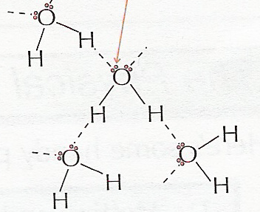

Circle the molecules that would exhibit hydrogen bonding:

H2O H2S CH4 NO2 CH3OH

Consider the four compounds, H2O, H2S, H2Se, and H2Te. Which one exhibits hydrogen bonding? ______

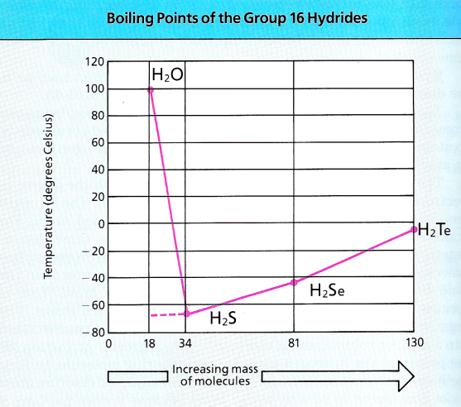

Look at this graph of boiling points. What effect does the hydrogen bonding have?

Using the diagram of ice and water to describe why ice (solid) is less dense than water (liquid) and why water expands when frozen. Relate the explanation to *hydrogen bonding*.

