**Scientific Method: Penny Drop Lab**

**With the scientific method in mind, design an experiment to determine which liquid will fit the most drops on a penny?**

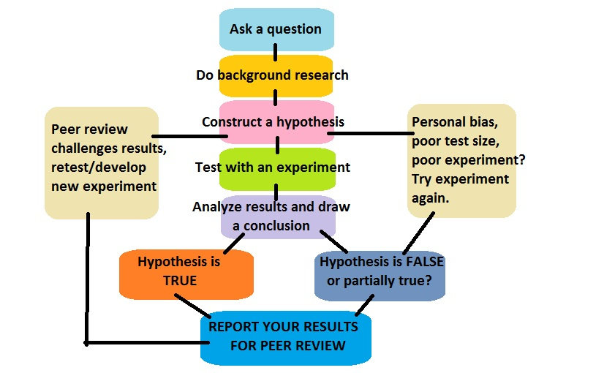

**Question:**

**Hypothesis**:

**Available Materials**:

* Penny
* Dropper
* Water
* Soapy Water

**Experiment/Procedure**:

**Analyze Data:**

Record both *qualitative* and *quantitative* observations throughout the experiment.

Data tables should be organized and appropriately labeled.

|  |  |  |
| --- | --- | --- |
|  |  |  |
|  |  |  |
|  |  |  |
|  |  |  |

**Reporting Results (Conclusion)**:

**Graphing**: arrange the independent/dependent variable axes, label axes, and add a title.

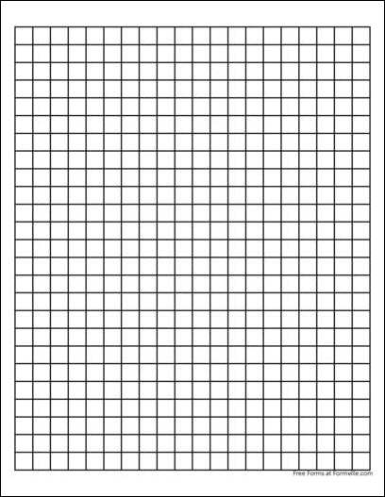

**Conclusion:** a write-up that addresses the following guiding questions:

* A description of how your team followed the scientific method in developing a conclusion (scientific reports do not use “I” statements).
* Identify the following:

control

independent variable

dependent variable

constant variable(s)

* How do your results compare to the other groups in class? Suggest at least 2 possible reasons for any similarities or differences in data.
* What does the data/results prove?

**Grading Rubric**

|  |  |  |  |  |
| --- | --- | --- | --- | --- |
|  | **4 pts** | **3 pts** | **2 pts** | **0 pts** |
| **Purpose/ Question, and Hypothesis:**  Are the purpose/ question, and hypothesis indicated? | The purpose/ question and hypothesis are appropriately designated and logically explained. | The purpose/ question and hypothesis are indicated and explained. | The purpose/ question and the hypothesis are indicated, but further reasoning is needed. | The purpose/ question and hypothesis are missing. |
| **Experiment:**  Are the control and independent/ dependent variables clearly included in the procedure? | Control and variables are accurately indicated and appropriately selected. The procedure is logical and replicable in answering the lab question. | Control and variables are present, but constant variables are not clearly identified. The procedure is logical and relevant. | Control or variables are reversed, or experimental procedure design does not answer the question or is not replicable. | Control or variables are missing. Experimental procedure development is flawed. |
| **Analyzing Data:**  Are all measurements from the lab clearly tabulated? | All data is clearly recorded and units of measure are indicated. | Data is present in an organized table, but units are not reported. | Data is mostly present, but is not organized into a table. | Data is missing, units are absent, and information is not organized. |
| **Graph:**  Does the graph appropriately report results? | An appropriate graph type is selected, the I/D variables are on the proper axes, axes are labeled and designated with units, scaling is appropriate, and there is a title. | An appropriate graph type is selected, the I/D variables are on the proper axes, axes are labeled, scaling is generally appropriate, and there is a title. | A graph is created. Axes are labeled and the graph has a title. The I/D variable axes are switched or there is no consideration to uniform scaling. | A graph is missing. |
| **Conclusion:**  Do conclusions refer to the data and observations collected during the activity? | Answers to all conclusion questions are logical and make clear reference to the data recorded for the experiment. | Answers to some conclusion questions are logical and make clear reference to the data recorded for the experiment. | Answers to the conclusion questions are consistent with the data but do not use the data as support. | Answers to conclusion questions are not supported by the data collected. |