**Cell Specialization/ Differentiation**

****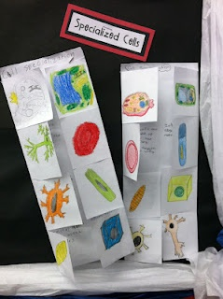

1. Create a foldable with 8 flaps (see example above)
2. Select 8 specialized cells (see possible examples below, or research your own example)
3. On the outside of the flap, draw a color picture of the specialized cell
4. On the inside of each flap, describe how the specific structure relates to the specific function of the specialized cell
5. In th center of the foldable, describe in general, how the organization of cells is similar, yet cells are differentiated/ specialized with specific structures and functions

**Example Specialized Cells:**

Muscle cell

Nerve cell

Red Blood cell

White Blood cell

Sperm cell

Egg cell

Bone cell

Skin cell

Plants: Pollen

Plants: Root cell

Plants: Guard cell