Honors Chemistry Final 2015

FINAL EXAM REVIEW

Honors Chemistry Final:

75 Multiple Choice Questions

10 Problem Solving (calculations)

5 Short Answer questions

Topics:
Energy, Thermodynamics
Stoichiometry
Gases
Solutions
Acids & Bases
Equilibrium
Kinetics, Reaction Rates
Electrochemistry

Resources for the final exam
- You should being your periodic table and ion chart.
- You may use a calculator (NO cell phones).
- You will be given the formula sheet (below):

Equations:

R = .0821 _{L • atm}
^{mol • K} 22.4L in 1 mole at STP

PV = nRT STP = 273K and 1 atm

P₁V₁ = P₂V₂ Molarity = mol
T₁ T₂ L

1 L = 1000 mL pH = -log [H⁺]

1 atm = 760 mmHg pOH = -log [OH⁻]

1 atm = 101.3 kPa pH + pOH = 14

M_{a}V_{a} = M_{b}V_{b}

Chapter 10: Stoichiometry

Vocabulary

- stoichiometry
- molar ratios

Be able to….

- Determine molar ratios
- Perform mole to mole conversions
- Perform multi-step conversions
  - (mass-mass, mass-volume, volume-volume)

Practice Problems:
- Use the following balanced equation to answer questions (2 points each)

2Al₂(CO₃)₃ + 3H₂SO₄ → 2Al₂(SO₄)₃ + 3 H₂O + 3CO₂

  - _________ What is the molar ratio for Al₂(CO₃)₃ and H₂O?
  - _________ How many moles of CO₂ are produced when 3 moles of H₂SO₄ react?
  - _________ How many moles of H₂O are produced when 2 moles of H₂SO₄ reacts?

- How many moles of oxygen are needed to react with 87g of lithium?
4Li + O₂ → 2Li₂O

- Use the equation to determine what mass of FeS must react to form 326g of FeCl₂. FeS + 2HCl → H₂S + FeCl₂

- If a piece of magnesium with a mass of 2.76g is added to a solution of hydrochloric acid (HCl), what mass of hydrogen gas would be produced?

- How many grams Au can be produced when 500 g of Rb is used to reduce it: ${\text{Au}}_{2}O_{3}+6\text{Rb}→3{\text{Rb}}_{2}O+2\text{Au}$

- How many grams of${\text{CO}}_{2}$ are liberated when 400 g of Propane is burned?
$C_{3}H_{8}+5O_{2}→4H_{2}O+3{\text{CO}}_{2}$

- How many grams in 4.2 moles of KNO₂?

Chapter 11: Heat & Energy

Vocabulary

- heat

  - temperature

Be able to….

- Identify exothermic vs endothermic reactions.
- Calculate heat absorbed or released by a reaction using q = mΔCT

Practice Problems:
- Label each reaction example as exothermic or endothermic

- 2H2(g) + O2(g) → 2H2O(g) ΔH°= -243 kJ ___________________
- H2B4O7(s) → B2O3(s) + H2O(l) feels warm ___________________
- H2B4O7(s) + H2O(l) → 4HBO2(aq) + 11.3 kJ ___________________

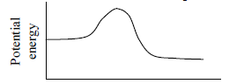 ___________________

- How much heat is required to heat 40.0g of water from 25.0ºC to 75ºC? (C=4.18 J/g⁰C)

- Be able to interpret a phase change diagram:

Chapter 12: Gases

Vocab:

- Kinetic Molecular Theory
- Atmospheric pressure
- Temperature
- Kinetic Energy
- Pressure
- STP

Be able to….
- Compare/ contrast the characteristics of solids/ liquids/ gases
- Describe the Kinetic-Molecular theory and explain how it explains gas behavior.
- Explain what gas pressure means and describe how it is measured.
- Solve problems using the gas laws.

Practice Problems:
- Compare the characteristics of solids/ liquids/ gases:
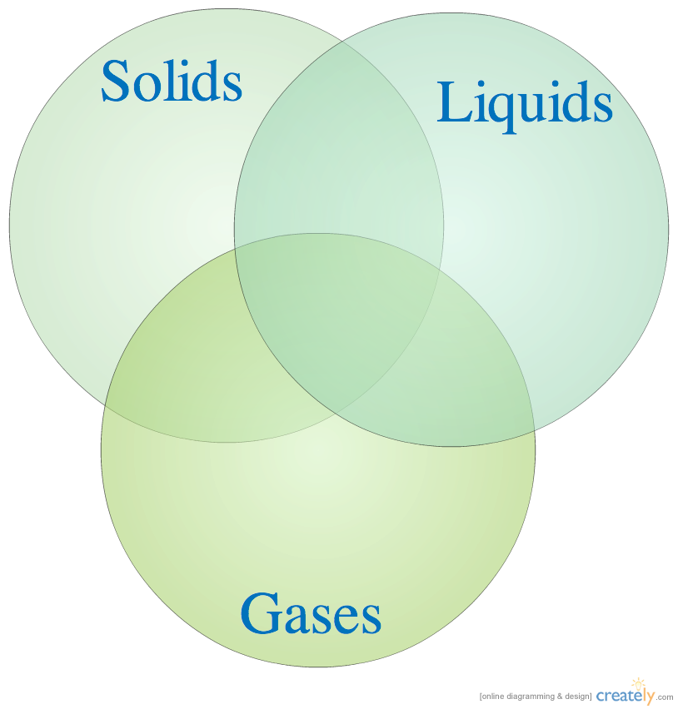
- A 3.00 liter sample of neon gas at 0°C and 1.25 atm is compressed into a 1.00 liter container. If the pressure remains constant, what temperature will the container be?

- What is the pressure exerted by 64 grams of oxygen confined to a volume of 500 mL at 20 °C?

- How many moles of gas are in a 52 L sample collected at 220 Kelvin and .444atm?

- Find the new volume when a 2.1 L sample of a gas collected at 245 Kelvin and 2.1atm is changed to standard conditions.

- Find the new volume of a gas that changes 65 ml at 150 mmHg to 425 mmHg.

- Explain the relationship between each of the variables for the following gas laws:

  - Boyle’s Law
  - Charles’ Law
  - Avogadro’s Law

Chapter 13: Solutions

Vocab

- solute
- solvent
- saturated
- unsaturated
- supersaturated
- polar/non-polar
- soluble
- insoluble

- miscible
- immiscible
- solubility curve
- solution
- colloid
- suspension
- molarity

Be able to…
  - Identify mixtures as solutions, colloids, or suspensions
  - Explain colligative properties and relate to practice applications
    - salting roads, ice cream
  - Interpret a solubility curve
  - Identify substances as saturated, unsaturated, or supersaturated
  - Calculate molarity

Practice Problems:
- Interpret solubility curves:
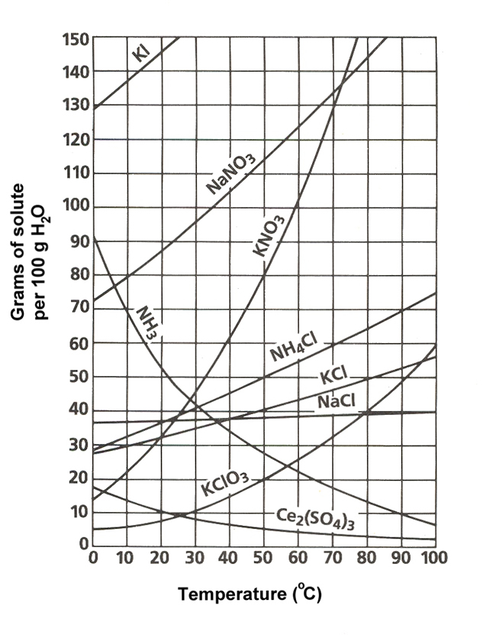
- What substance is most soluble at 20ºC?

- What substance is least soluble at 90 ºC?

- What is the solubility of KNO₃ at 50 ºC?

- How many grams of NaNO₃ can dissolve in 100 grams of water at 60° C?

- If 70g of KCl is dissolved at 70 ºC, is the solution saturated, unsaturated, or supersatured?
- _________ Calculate the molarity when 2 mol of CuSO₄ dissolves in 6L of water.

- _________ Find the molarity of NaCl when 20g are dissolved in 2500mL of water.

- _________ What mass of HCl is needed to prepare 1.5 L of a 0.010 M solution.

Chapter 15: Acids and Bases:

Vocabulary
- Arrhenius Acid, Base
- dissociation
- titration

Be able to…
- Identify substances in chemical equations as acids or bases
- Identify the common physical and chemical properties of acids and bases
- Calculate pH of solutions
- Determine an unknown concentration of an acid/base using titrations

Practice Problems:
- Label the properties of acids and bases:
 | Acids | Bases
Dissociates into ____ ions
pH range?
Taste?
Feels?
Conducts Electricity?
Turns Phenolphthalein ______

- _________ Find the pH of a 1.0 x 10⁻³ M solution of HCl

- _________ Find the pH of a .005 M NaOH solution.

- _________ What is the concentration of base if 40mL of NaOH is titrated with 80mL of 1M HCl? 3.

- Write the neutralization reaction for the reaction of KOH and HBr:

KOH + HBr →

Chapter 16: Reaction Rates

Vocabulary
- Collision Theory
- Catalyst

Be able to…
- Describe the two conditions for a successful chemical reaction
- Understand chemical reactions in terms of collision theory
- Be able to list and describe the factors that affect reaction rates
- Interpret potential energy diagrams

Practice Problems:

- What are the two conditions for a successful reaction?

- Explain how the following factors change reaction rates:

- surface area of a solid reactant

- concentration or pressure of a reactant

- temperature

- presence of a catalyst

