Name Date
Survival of the Fittest— Variations in the Clam Species Clamys sweetus
Introduction
Two important observations Charles Darwin made during his travels were (1) living things occupy a planet that is constantly changing and (2) living things change over time. These two observations led him to the concept of “descent with modification.” Darwin wrote that the presence of variations within species fuels the process of change over time—evolution.
It is easy to understand how variations within a species increase or decrease an individual’s chance of survival. Whenever there is competition, there are winners and losers.
Setting the Scene
Clamys sweetus is a newly discovered species of clam. It had gone undiscovered until recently due to its small size and the remoteness of the area it inhabits. Two symmetrical shells connected by a hinge joint protect its soft body. C. sweetus, like other clams, eats plankton and in turn is eaten by small sharks and squid. In order to better understand C. sweetus and how it has changed over time, it is important to study variations present within the population.
Materials
• 1 container of C. sweetus strain M • competition grid
• 1 container of C. sweetus strain R • small metric ruler
• 1 waste container • Optional: electronic balance
• colored pencils/markers (red, blue, yellow, orange, and green)
Safety
Do NOT eat the C. sweetus. They may be contaminated. Some C. sweetus contain peanut products.
The Survival of C. sweetus: Part One—Observations
Observations of Clamys sweetus
1. Your container labeled “C. sweetus strain M” holds 10 individuals. Without removing them from the bag, observe and record at least 4 traits you could use to accurately describe the appearance of this organism.

2. Your container labeled “C. sweetus strain R” also holds 10 individuals. Without removing them from the bag, observe and record at least 4 traits you could use to accurately describe their appearance.

3. Based on your observations, are there any distinct differences between C. sweetus strain M and strain R? Support your answer with information recorded in observations 1 and 2.

Observations of Clamys sweetus—continued
Additional observations of variations within the C. sweetus species require that different tests be performed on the clams. For example, you cannot tell if one clam has a stronger shell than another by just looking at them. To find this out, tests must be conducted. This is the basis of the next activity.
Procedures
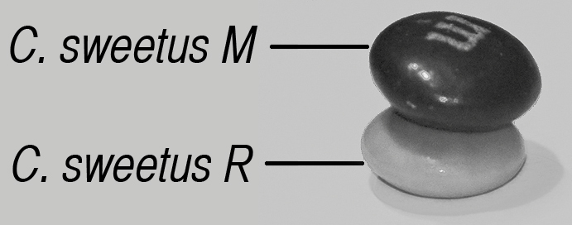
  - Select one C. sweetus M and one C. sweetus R from your containers and place them as a pair on the appropriate circles on Chart 1: Relative shell hardness.
Figure 1: Stack of clams
Before starting the experiment, all 10 pairs should be in place.
1-2. To determine which clam has the stronger shell, pick up the first pair of C. sweetus strain M and strain R clams. Stack one on top of the other as illustrated in Figure 1: Stack of clams.
1-3. Hold the two clams so that your thumbs are on the bottom surface and your index fingers are placed securely on the top. See Figure 2: Crushing technique.
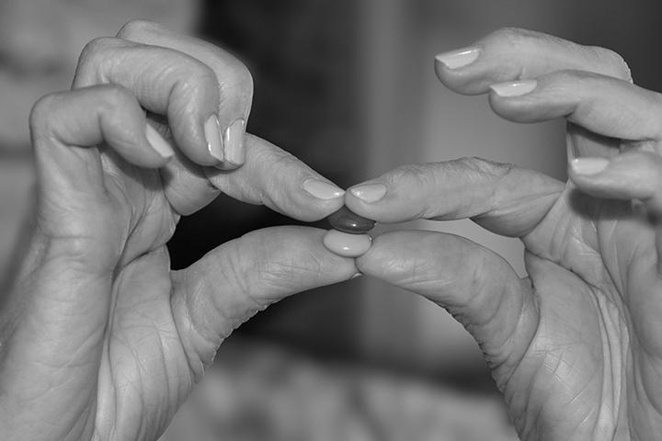
1-4. Evenly apply pressure to the top and bottom of the stack. As soon as one of the shells cracks, stop. Examine the two specimens and determine which one cracked first*.
Figure 2: Crushing technique
1-5. Indicate the survivor by recording the appropriate letter in the circle in the Strain of winner column. Place both clams in the waste container.
*Note: If it is impossible to determine which clam cracked first, record the one whose shell cracked the least in the Strain of winner column.
1-6. Repeat the above procedures (1-2 through 1-5) a total of 10 times.
1-7. In Chart 2, record the number of each variation present in the population before and after crushing.
1-8. In Chart 2, also record the data collected by the entire class. Use this data to calculate the percent frequency of each strain present in the population before and after crushing.

The percent frequency is a measure of the number of one strain that is present in the population divided by the total number present multiplied by 100. In this case, the total number would be equal to the sum of strains M and R.
Percent Frequency = (C. sweetus R / total number of clams) x 100
Example:
If there are 100 clams in a population and 20 clams are C. sweetus R and 80 are C. sweetus M, then:
Step 1: Percent Frequency of C. sweetus R clams = (20 C. sweetus R/ 100 total clams) x 100
Step 2: Percent Frequency of C. sweetus R = (20/100) x 100
Step 3: Percent Frequency of C. sweetus R = .2 x 100 = 20%
Analysis
4. (a) Use the grid provided below to construct a bar graph that shows the percent frequency of C. sweetus strains M and R in the class clam population after crushing. Plot only class data. The percent frequency of both strains before crushing has been plotted for you.
(b) Be sure to provide a title and appropriate labels.
Title: ___________________________________________________

100%
90%
80%
70%
60%
50%
40%
30%
20%
10%
Strain M before crushing
Strain R before crushing
5. When analyzing the results, why is it important to use class data and not just the data obtained by an individual team?

6. Is there a difference in shell strength between the two varieties? Support your answer with data from Chart 1: Relative shell hardness.

Setting the Scene
Several years ago, a predatory arthropod was accidentally introduced into the area inhabited by C. sweetus. The arthropod looks like a crab and has pincers specialized for cracking open shells. Recent studies indicate that C. sweetus has become its preferred food. In other regions of the ocean, the arthropod primarily consumes soft-shelled clams. There are no soft-shelled clams in the area where C. sweetus is presently found.
7. (a) The arthropod is able to crack open only relatively weak clam shells. If it could tell the difference, which variety might the arthropod seek out as it hunts for food? Support your answer.

(b) Describe how this feeding preference might affect the numbers of the two varieties in this and future populations of C. sweetus.

The Survival of C. sweetus: Part Two
Recall that a foreign species that feeds on soft-shelled clams was accidentally introduced into the habitat occupied by C. sweetus. A research team investigating the impact of the predatory arthropod on the C. sweetus population hypothesized that shell color and hardness are related. To test this hypothesis, the team suggested that they conduct an experiment similar to the one done in Part One. This time only C. sweetus strain M is used and the pairs being crushed always consist of two different colors.
2-1. Select individuals from your C. sweetus strain M container and place them on the appropriate circles on Chart 3: Relative shell hardness. Before starting the experiment, each pair of clams should be in place.
2-2. Once all of the individuals are positioned on the chart, begin this part of the investigation by stacking a Yellow and Blue clam and applying pressure. Indicate which has the hardest shell by recording the appropriate letter in the circle in the Color of hardest shell column. You may want to use a colored pencil/marker to color the circle the color of the survivor. (Refer to steps 1-1 through 1-5 of Part One for stacking and crushing directions.)
Next, repeat the process using a Yellow and an Orange clam (See chart). Continue to work down the chart until all of the pairs have been tested and the data recorded.
2-3. Use Chart 4 to summarize your findings. Record the percent frequency of each color present in the clam population before and after crushing for both your team and the class.
8. Use the grid below to construct a bar graph. It should show the percent frequency of each color present in the population before and after crushing.
• Plot only class data.
• Use colored pencils/markers.
• Be sure to provide a title, a key, and to label the axes.
Title: ________________________________________________
KEY

Analysis
9. (a) Based on class results, which two colors experienced the greatest change in percent frequency? Use specific data to support your answer.

(b) How can these changes be used to predict the percent frequency of these two color variations in future C. sweetus populations?

10. Within a population, there are variations of a given trait present. For example, people in a given age group vary in height. There are a few very tall and very short individuals. Most people fall into the average height range.
You have found that the shells of C. sweetus clams vary in relative hardness. The graph below illustrates the range in shell hardness found in clams with red shells.

Title: Range in shell hardness of red C. sweetus clams
Relative number of  individuals at each level | 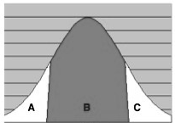
Increasing shell hardness
Which red-shelled clams, those in region A, B, or C, are the most likely be consumed by the predatory arthropod? Explain.

11. Researchers compared the relative hardness of the shells of two different color variations in C. sweetus M. When plotted, the data collected during these trials resulted in the graph below.
Title: Relative shell hardness in C. sweetus clams
Relative number of  individuals at each level | 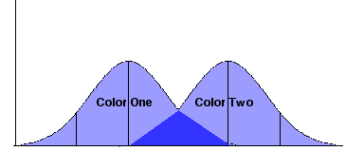
 | Increasing shell hardness
(a) Based on your class results:
Which color variation does Color One represent? __________________
Which color variation does Color Two represent? __________________
(b) Which clams, those with Color One or Color Two shells, would most likely survive an attack by the predatory arthropod? Support your answer with information from the graph.

(c) In the area where the two curves overlap, which clams (Color One, Color Two, or both) would be most likely to survive? Explain.

12. How might variations present in the predatory arthropod affect the future of the C. sweetus population?

The Survival of C. sweetus: Part Three
You and your research team have been studying C. sweetus for many years when a new color variation suddenly appears. A number of brown clams are found in several locations. The presence of these brown clams raises many questions.
13. Discuss with your lab partner what you have learned about C. sweetus strain M. Formulate and record a hypothesis about the ability of brown clams to survive predation by the predatory arthropod. Design an experiment that you could conduct to test your hypothesis.
Hypothesis:

Materials:

Independent Variable:

Dependent Variable:

Procedures:

Even after conducting your experiment, there are many questions that remain unanswered. You are given approval to attend a scientific meeting in order to ask other researchers some of the questions your research team has about these brown clams.
14. Compile a list of questions you will ask during the meeting.

Summary
15. a. Examine the chart below. Read the information provided in the Environmental Factor, Present Day, and Possible Environmental Change columns.
b. As time passes, changes take place. Select one factor to change from the Possible Environmental Change column. Indicate your choice by circling it.
The environmental change you circled will result in some of the variations present in the clam population being selected for and others selected against. It is also possible that new variations may arise as a result of random mutations and the recombination of genes during sexual reproduction. With this in mind, in the chart provided, make two drawings:
Drawing Number 1: illustrate the present environment inhabited by C. sweetus
Drawing Number 2: illustrate the future environment inhabited by C. sweetus
Be sure that your drawings show:
• any changes in the ocean floor or water quality
• C. sweetus in each environment
• one or more predatory arthropods
Use labels to clarify your drawings.

Environmental Factor | Present Day | Possible Environmental Change
Ocean Floor | Many corals and colorful anemones cover the ocean floor. | Dark rocks are exposed; brown algae grows on them
Water Quality | The water is clear with much light reaching the bottom. | The water is not clear. There is much suspended sediment with little light penetration

Drawing Number 1: C. sweetus in Present Day Environment | Drawing Number 2: C. sweetus in Future Environment

c. Record the environmental change you selected and explain how it has influenced the evolution of C. sweetus in the ways you have shown.

16. Examine the cartoon below. Which person is correct? Explain why this individual is correct and the others are not.
What is the role of natural selection in evolution?

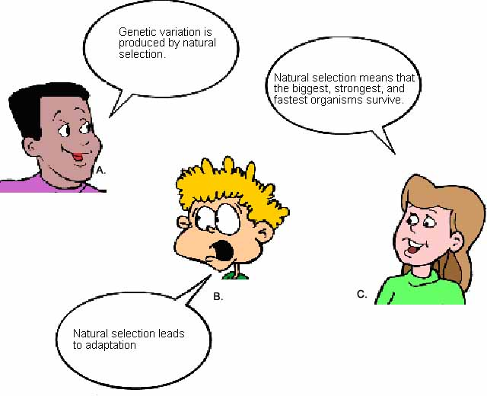

Chart 1: Relative shell hardness

C. sweetus  top of stack | C. sweetus  bottom of stack | Strain of winner
 |  |  |  | Key | C. sweetus  strain R |  | C. sweetus  strain M

Chart 2: Percent frequency of C. sweetus M and C. sweetus R before and after crushing
Number and percent frequency of each strain  in original population | Number and percent frequency of each strain  after crushing
Team Results
Population = 20 Population = 10
No. of R = 10 % Freq. of R = __50%__ | No. of R = _______ % Freq. of R = _________
No. of M = 10 % Freq. of M = _50%__ | No. of M = _______ % Freq. of M = _________
Class Results
Population = _____ Population = _____
No. of R = _______ % Freq. of R = _________ | No. of R = _______ % Freq. of R = _________
No. of M = _______ % Freq. of M = _________ | No. of M = _______ % Freq. of M = _________
Remember: Percent Frequency = (number of clams of one strain / total number of clams) x 100

Chart 3: Relative shell hardness |  |  |  | Chart 4: Percent frequency of shell color before and after crushing
C. sweetus color  top of stack | C. sweetus color  bottom of stack | Color of hardest shell |  | Percent frequency of each color before crushing | Percent frequency of each color after crushing
Team Results
Population = 20 Population = 10
 |  |  |  | Yellow = __20%_ | Yellow = _______
 |  |  |  | Orange = __20%_ | Orange = _______
 |  |  |  | Red = __20%_ | Red = _______
 |  |  |  | Blue = __20%_ | Blue = _______
 |  |  |  | Green = __20%_ | Green = _______
Class Results
Population = _____ Population = _____
 |  |  |  | Yellow = _______ | Yellow = _______
 |  |  |  | Orange = _______ | Orange = _______
 |  |  |  | Red = _______ | Red = _______
 |  |  |  | Blue = _______ | Blue = _______
 |  |  |  | Green = _______ | Green = _______
Remember: Percent Frequency = (number of clams of one color / total number of clams) x 100

