CELL STRUCTURE | Type of Cell  Prokaryote/ Eukaryote?  Bacteria? Plant or animal? | FUNCTION
Cell Wall
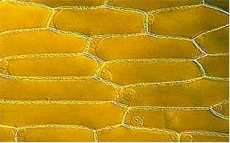
Cell Membrane
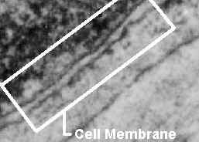
Nucleus
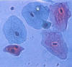
CELL STRUCTURE | Type of Cell  Prokaryote/ Eukaryote?  Bacteria? Plant or animal? | FUNCTION
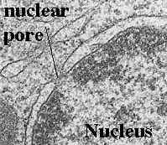
Nuclear membrane
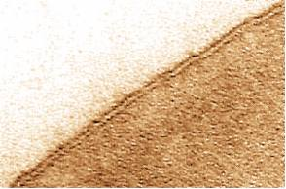
Cytoplasm
Endoplasmic
reticulum (ER)
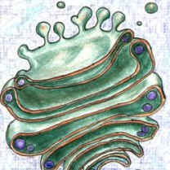
CELL STRUCTURE | Type of Cell  Prokaryote/ Eukaryote?  Bacteria? Plant or animal? | FUNCTION
Ribosome
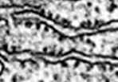
Mitochondrion
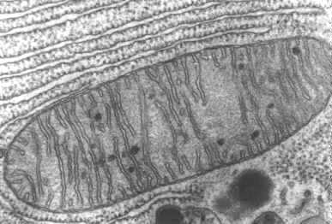
Vacuole
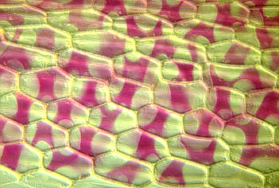
CELL STRUCTURE | Type of Cell  Prokaryote/ Eukaryote?  Bacteria? Plant or animal? | FUNCTION
Lysosome
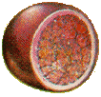
Chloroplast
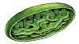
nucleolus
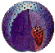
Golgi Apparatus
CELL STRUCTURE | Type of Cell  Prokaryote/ Eukaryote?  Bacteria? Plant or animal? | FUNCTION
Cilia
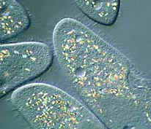
Flagellum
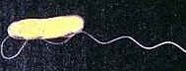
Centrioles
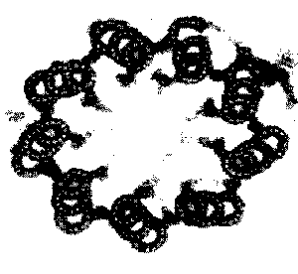
Cytoskeleton
